Power sharing between parallel inverters by using droop control with a secondary control loop

Li Lei
School of Engineering
Newcastle University
Newcastle upon Tyne, NE1 7RU, UK
l.lei2@ncl.ac.uk
Mohammed A. Elgendy
School of Engineering
Newcastle University
Newcastle upon Tyne, NE1 7RU, UK. mohammed.elgendy@ncl.ac.uk
Neal Wade
School of Engineering
Newcastle University
Newcastle upon Tyne, NE1 7RU, UK.
neal.wade@ncl.ac.uk
Salaheddine Ethni
School of Engineering
Newcastle University
Newcastle upon Tyne, NE1 7RU, UK
salaheddine.ethni@ncl.ac.uk

Abstract—Analysis of power sharing between parallel grid-connected inverters is a popular topic in the microgrid research area. In this paper, droop control with a secondary control loop is presented for an AC microgrid, to improve the accuracy of power sharing performance between parallel inverters. The secondary control loop calculates the reference active power and reactive power input to P-f/Q-V droop control. The proposed method can be used in microgrids which contain many micro sources and loads variations for both islanding and grid-connected operation modes. A simulation model for a microgrid with three generators is built to test the performance of the proposed control method using MATLAB/SIMULINK platform. Results of the new method are compared with the virtual impedance droop control method to illustrate the advantages of the proposed power-sharing method.
Keywords—Distributed generation, droop control, parallel operation of inverters, power sharing.

Introduction
Power inverters are the most important part in a grid-connected microgrid that integrate conventional distributed generation (DG) units, energy storage systems and renewable energy sources to form a smart grid configuration [1, 2]. These inverters are often connected in parallel. Therefore, achieving stable parallel operation and a reasonable load power sharing has become a serious problem [3].
Many solutions to the power-sharing problem have been proposed in the literature, especially with the use of droop control techniques. Droop control makes use of the local measurements to provide a decentralized control which does not rely on any external communication links, this enables plug and play operation and also improves the reliability of the system [4-6]. In [7], equal power sharing is achieved by adjusting the output impedance and the frequency during the load transients. In [8], drooping the virtual flux has been used instead of the inverter output voltage to avoid the frequency and voltage deviations and to achieve equal power sharing. In addition, in order to improve load reactive power sharing in proportional to the capacities of the inverters more accurate, a small signal injection method has been used [9]. However, most of the control methods in literature cannot achieve the active power and reactive power at the same time; or they can only be working on the island mode, not working on grid-connected mode.
Communication line can also be used in conjunction with the droop control method to provide measurements that can be used instead of line impedances, eliminating the error in line impedance estimation. This improves system reliability and performance [10-12]. In this case, the overall control scheme of a distributed generation system can be divided into four levels; inner control loop, local control loop, secondary control loop and global control loop [13]. The relationship between them is shown in Fig.1.
In this paper, droop control is employed in the local control loop while the reference active and reactive power to the droop control is provided by the secondary control loop. Compared to virtual impedance method, the proposed control method can achieve equal power sharing between inverters with the same capacity regardless of the line impedance value of every inverters. It can also achieve equal inverter loading when the rated power of the inverters is different. In addition, the proposed control method can achieve stable output voltage and frequency with loads and generators plug in or plug out.

Droop Control
Traditional droop control can be divided into P-f/Q-V droop control and P-V/Q-f droop control based on the impedance$Z=r+jX$, where $r$ is the sum of output resistance and line resistance and $X$ is the sum of output reactance and line reactance. P-f/Q-V droop control is used, $X$ is much larger than $r$, while in P-V/Q-f droop control, $r$ is much bigger than $X$[14]. This paper is more concerned with low voltage grids where $X$ is much larger than $r$ and therefore, P-f/Q-V droop control will be used. P-f/Q-V droop control is based on the relationship between the active power and frequency of the grid-connected inverter and the relationship between its reactive power and voltage, similar to the droop characteristic of the synchronous generator.
Figure 1. Relationship between four control scheme levels.
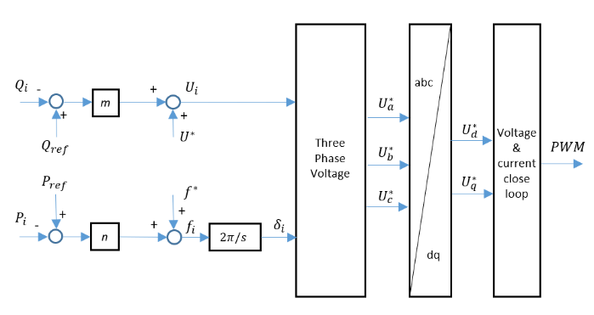
Figure 2. Traditional P-f/Q-V droop control

Fig 3 Block diagram of conventional droop control with Virtual impedance loop.

P-f/Q-V droop control.
With P-f/Q-V droop control, the following equations are used.
$f_{i}=f_{0i}-m_{i}(P_{i}-P_{0i})$ (1)
$U_{i}=U_{0i}-n_{i}(Q_{i}-Q_{0i})$ (2)
where:$f_{i}$ and $U_{i}$ are the angular frequency and output voltage amplitude respectively; $f_{0i}$ and $U_{0i}$ are the frequency and the rms value of the reference voltage respectively; $m_{i}$ and $n_{i}$ are the frequency droop coefficient and voltage droop coefficient; $P_{i}$ and $Q_{i}$ are the actual output active and reactive power of the inverter respectively; $P_{0i}$ and $Q_{0i}$ are the active power and reactive power outputs that DGs can supply.
Fig. 2 shows how the traditional P-f/Q-V droop control is used to control a grid-connected inverter.

Virtual impedance droop control.
The conventional droop control cannot provide a balanced reactive power sharing among parallel-connected inverters under line impedance mismatch. Therefore, the imbalance in reactive power sharing is a serious problem in an AC microgrid. Also, the traditional P-f/Q-V droop control of the inverter assumes that the line resistance is much smaller than the line reactance and does not consider the different conditions of different inverter circuit reactance. The method of adding the virtual impedance in the control can improve the inductive component of the inverter output impedance, but the excessive virtual resistance will reduce the output voltage and reduce the power quality [15].
As shown in Fig. 3, the reference voltage from each inverter can then be modified, as follow:
$V_{ref}=V_{0}-Z_{V}I_{0}$ (3)
where$Z_{V}$is the virtual output impedance.
The equivalent model and phasor diagram of the virtual impedance is shown in Fig. 4. The virtual impedance is generally selected to compensate for line impedance variations. So, the virtual output impedance can be chosen by the summation approach, in which balanced reactive power sharing is achieved if the voltage drops from every inverter to AC bus:
$V_{drop1}=\left(Z_{l1}{+Z}_{v1}\right)I_{l1}=V_{drop2}=(Z_{l2}{+Z}_{v2})I_{l2}$ (4)
In this equation, $Z_{v1}$ and $Z_{v2}$ are the virtual output impedance of two parallel connected inverters, moreover, $Z_{l1}$ and $Z_{l2}$ are line impedance of two parallel connected inverters.
In the summation approach, one virtual output impedance is set to zero, and another virtual output impedance is set to emulate the line impedance. Based on the equation and considering that one-line impedance is larger than another, that is $Z_{l1}{>Z}_{l2}$, which permits the selection of $Z_{v1}=0$ and the equation can be simplified as:
$Z_{v2}{=Z}_{l1}-Z_{l2}$ (5)
The value of the virtual impedance is decreased using the summation approach, which minimizes the degradation of voltage regulation. Reactive power sharing is improved if the change in output voltage is markedly higher than the voltage drops across the line than the reactive power. However, the virtual impedance droop control also has some disadvantages, such as it cannot achieve active and reactive sharing in both islanded mode and grid connected mode, this will be shown in the next simulation results part.
(a)
(b)
Fig 4. (a) Equivalent model of a virtual impedance and (b) phasor diagram.

Proposed Control Method
Proposed control method included two important parts, one is the droop control loop, and the other is a secondary control loop. The reference signals to the droop control are generated by the secondary control loop. In this paper, the secondary control loop collects output active power and reactive power data from every working inverter, calculates total active and reactive power output from all inverters, calculates the average loading factor considering inverters’ power ratings, and then calculates the active and reactive power reference signals to the droop control to maintain equal inverter loading, as shown in Fig. 5. When inverters have equal power ratings, inverters can output equal active power and reactive power, no matter the line impedance values of themselves.

Simulation Results
The microgrid considered in this paper comprises three parallel inverters, two loads and is connected to the main grid. The three parallel inverters have totally different line impedance values to simulate the different distance from the micro source to PCC. One of the two loads is 2000W active power while the other is 2000W active with 600var inductive reactive power. For the grid, the phase to phase voltage is 380V and the frequency is 50Hz. The different parameters of the system are summarized in Table I.
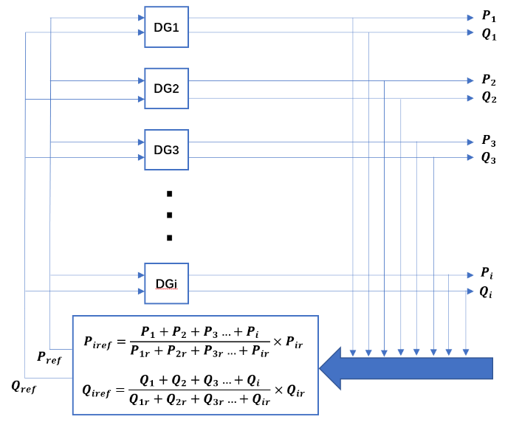
Figure 5. Secondary control loop

TABLE I. PARAMETER OF THE SYSTEM
 | Parameters | Value
DG units | Inverter switching frequency | 10kHz
DG units | DC bus voltage | 800V
DG units | Nominal bus frequency | 50Hz
DG units | RMS line voltage | 380V
DG units | Line impedance(DG1) | 2.64mH, 1.642Ω
DG units | Line impedance(DG2) | 1.32mH, 0.821Ω
DG units | Line impedance(DG3) | 5.28mH, 3.284Ω
Load | Load 1 | 2000W
Load | Load 2 | 2000W+600var
Grid | Phase to phase voltage | 380V
Grid | Frequency | 50Hz
In the normal operation mode, all parallel inverters and the resistive load are always connected to PCC. Another inductive load is connected to PCC at 0.5s and disconnected at 1.5s. The grid is connected to PCC from 1s to 2s, then disconnected from the system, as shown in Table II.
Three different case’s simulation results are shown below, they are: virtual impedance droop control, the same inverter rated capacity with proposal method, and the different inverter rated capacity with proposal method.

Virtual impedance droop control.
Figs. 6-8 show simulation results when using the virtual impedance droop control method when the line impedances are kept constant at the actual island mode values. Since the virtual impedance control method is adopted, the output impedances of the three inverters are almost the same, so the waveforms generated by the three inverters are basically the same. When the grid is connected, the total line impedance will be incorrect and the active and reactive power of the inverters will significantly exceed the ratings.
TABLE II. OPERATION MODE
Breaker number | Time | Operation
1 | 0.5s to 1.5s | Load 2 connected to the system at 0.5s and disconnected at 1.5s.
2 | 1.0s to 2.0s | Utility grid connected to the system at 1.0s and disconnected at 2.0s.
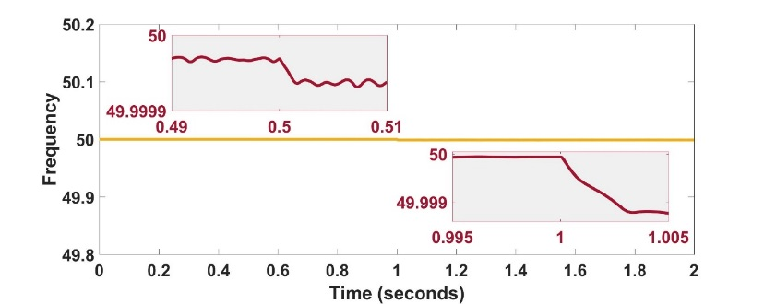
Figure 6. The frequency of 3 inverters by using virtual impedance droop control.
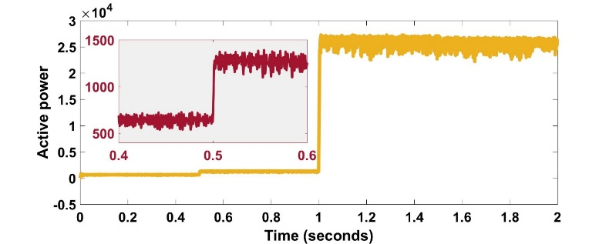
Figure 7. The output active power of 3 inverters by using virtual impedance droop control.
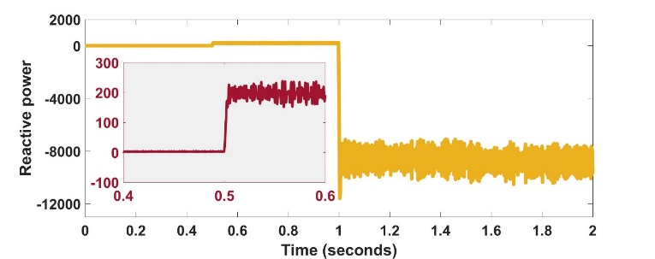
Figure 8. The output reactive power of 3 inverters by using virtual impedance droop control.
Fig. 6 shows that line frequency remains stable with a minor reduction when the grid is connected (at 1s). Fig. 7 shows the simulation results of active power. As shown, power sharing is achieved before and after grid connection. Before the grid connection, load power is equally shared between the three inverters. However, after the grid is connected to the system, all three inverters generate a large output active power that exceeds their ratings. This is due to the use of constant line impedance which becomes incorrect after the grid is connected. This shows how sensitive the inverter control to the accuracy of line impedance estimation. Similarly, reactive power sharing is achieved but significantly large reactive power is observed after grid connection, as shown in Fig.8. Therefore, for the virtual impedance droop control, although the same power output can be maintained between the inverters, system performance is very sensitive to the accuracy of line impedance estimation. The use of inaccurate line impedance values will result in wrong calculation of the virtual impedances and may result in system instability and violation of inverter’s healthy operation boundaries.

Equal inverter power rating of three parallel inverters by using proposed control.
The proposed control method is examined with equal and unequal inverter ratings. The results shown in Figs. 9-12 are for the equal power rating case. Fig. 9 shows that the frequency of all the three inverters remains stable with 0.1Hz maximum deviation from 50Hz when the microgrid is switched between islanded and grid-connected operation or subjected to a step load variation. Fig.10 shows the output phase to ground voltages of the three inverters are well stable at 311V. For the currents of DG1, DG2 and DG3 shown in Fig. 11, all have the same value with an increase between 0.5s to 1.5s, due to the connection of the second load (the inductive load). When the grid is connected, the load current is shared between the inverters and the grid resulting in a reduction in inverter currents. Fig.12 shows that the three parallel inverters, although they have different line impedance from each other, have equal output active power and reactive power, which track the load changes.
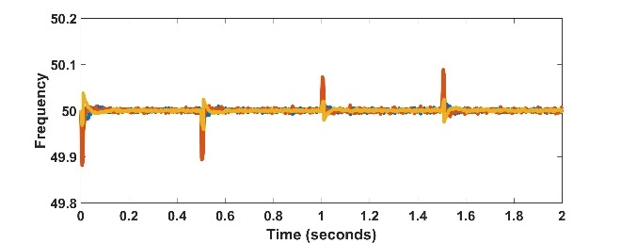
Figure 9. Frequency of 3 inverters by using proposed control.

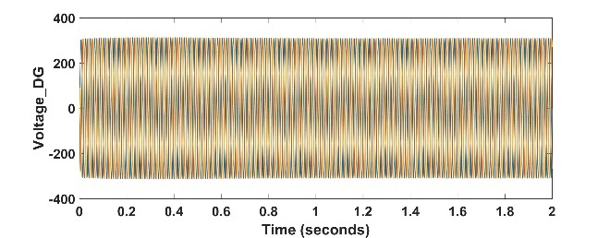
Figure 10. Output voltage and output current of 3 inverters by using proposed control.
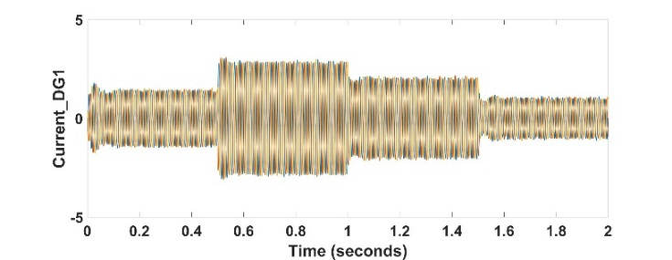
(a)

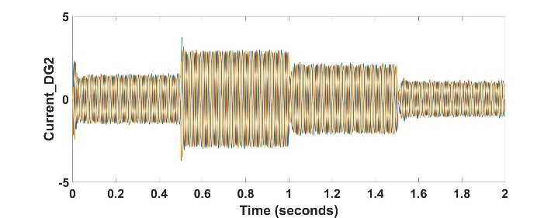
(b)

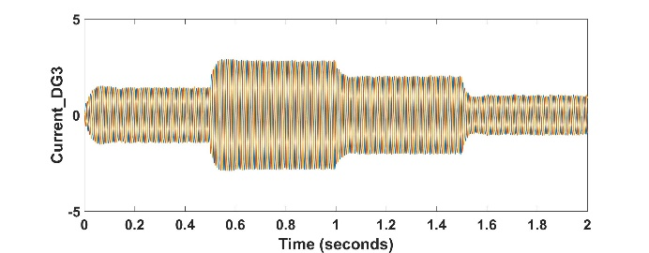
(c)
Figure 11. Output current of 3 inverters by using proposed control: (a) current of DG1, (b) current of DG2, (c) current of DG3.

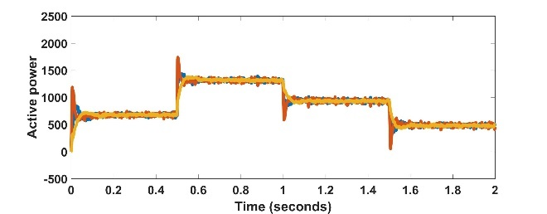
(a)

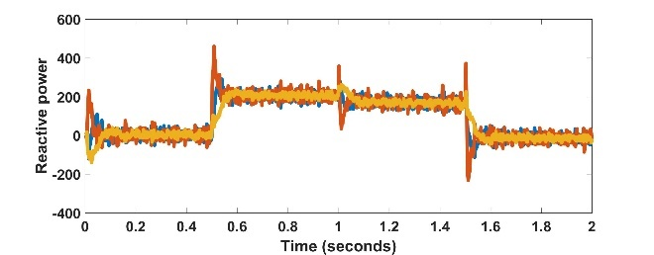
(b)
Figure 12. Output active power and output reactive power of 3 inverters by using proposed control: (a) active power, (b) reactive power.

Unequal inverter power rating of three parallel inverters by using proposed control.
The results shown below are for the unequal power rating case. In this case, it is assumed that the inverter capacity proportion is DG1: DG2: DG3=3:2:1.
As can be seen from these figures, with different power ratings of the inverter, the output frequency of the three inverters has not changed and remains in about 50Hz. The output voltage also did not change and was always stable at 311V. For the output current, shown in Fig.15, is proportional to the rated capacity of the inverter; i.e. $I_{DG1}:I_{DG2}:I_{DG3}=3:2:1.$ Therefore, the output active power and reactive power of the three inverters are also kept at this ratio, whether there is a new load intervention or exit, or the switching of the operating mode (from island operation to grid-connected operation), can follow the capacity of the inverter to achieve stability (Fig.16). Therefore, compared with the common virtual impedance droop control method, the control method proposed in this paper has a greater advantage, and the load power can be distributed according to the capacity of the inverter under different situations.

Conclusions
In this paper, the problem of power sharing between parallel grid-connected inverter is solved by the proposed droop control with a secondary control method. Firstly, the traditional droop control method was discussed and their disadvantage in parallel grid connected inverter is highlighted. Then, a popular control method named virtual impedance droop control is analysed and its drawback compared to the proposed control method is discussed. A simulation model was built to analyse the performance of the proposed control method, and to compare with the simulation of the virtual impedance control method. The results show that the droop control with the secondary control loop has much better performance than virtual droop control method.

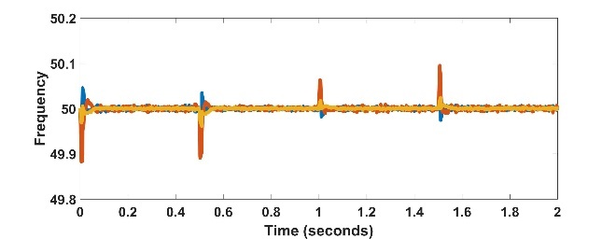
Figure 13. Frequency of 3 inverters by using proposed control.

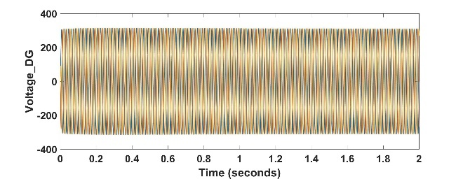
Figure 14. Output voltage and output current of 3 inverters by using proposed control.

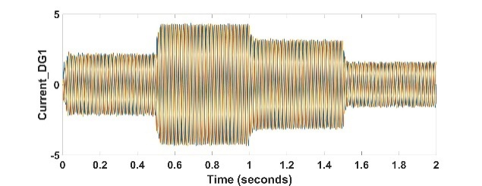
(a)

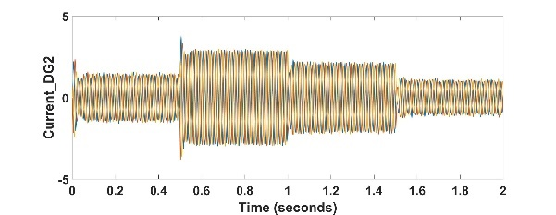
(b)

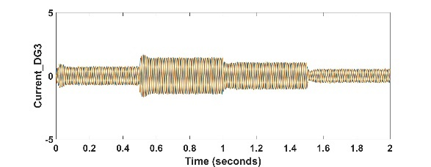
(c)
Figure 15. Output current of 3 inverters by using proposed control: (a) current of DG1, (b) current of DG2, (c) current of DG3.

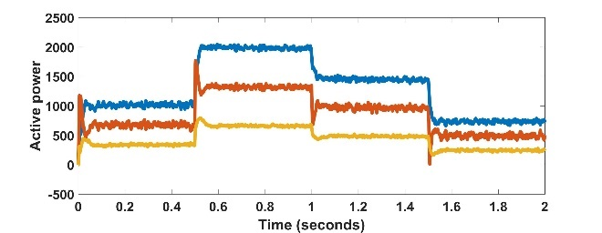
(a)

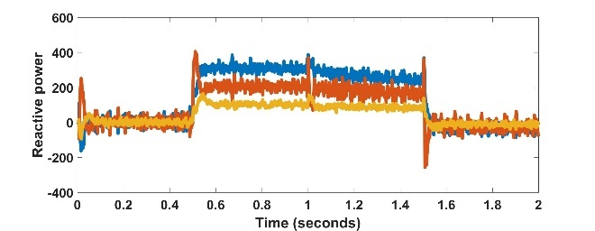
(b)
Figure 16. Output active power and output reactive power of 3 inverters by using proposed control: (a) active power, (b) reactive power.

References
[1] Q.-C. Zhong and T. Hornik, Control of power inverters in renewable energy and smart grid integration. John Wiley & Sons, 2012.
[2] X. Fang, S. Misra, G. Xue, and D. Yang, "Smart grid—The new and improved power grid: A survey," IEEE communications surveys & tutorials, vol. 14, no. 4, pp. 944-980, 2012.
[3] Q.-C. Zhong and Y. Zeng, "Universal droop control of inverters with different types of output impedance," IEEE Access, vol. 4, pp. 702-712, 2016.
[4] C. Guzman, A. Cardenas, and K. Agbossou, "Load sharing strategy for autonomous AC microgrids based on FPGA implementation of ADALINE&FLL," IEEE Transactions on Energy Conversion, vol. 29, no. 3, pp. 663-672, 2014.
[5] Q.-C. Zhong and Y. Zeng, "Parallel operation of inverters with different types of output impedance," in IECON 2013-39th Annual Conference of the IEEE Industrial Electronics Society, 2013, pp. 1398-1403: IEEE.
[6] H. Mahmood, D. Michaelson, and J. Jiang, "Accurate reactive power sharing in an islanded microgrid using adaptive virtual impedances," IEEE Transactions on Power Electronics, vol. 30, no. 3, pp. 1605-1617, 2015.
[7] J. M. Guerrero, L. G. De Vicuna, J. Matas, M. Castilla, and J. Miret, "Output impedance design of parallel-connected UPS inverters with wireless load-sharing control," IEEE Transactions on industrial electronics, vol. 52, no. 4, pp. 1126-1135, 2005.
[8] J. Hu, J. Zhu, D. G. Dorrell, and J. M. Guerrero, "Virtual flux droop method—A new control strategy of inverters in microgrids," IEEE Transactions on Power Electronics, vol. 29, no. 9, pp. 4704-4711, 2014.
[9] A. Tuladhar, H. Jin, T. Unger, and K. Mauch, "Control of parallel inverters in distributed AC power systems with consideration of line impedance effect," IEEE Transactions on Industry Applications, vol. 36, no. 1, pp. 131-138, 2000.
[10] J. M. Guerrero, M. Chandorkar, T.-L. Lee, and P. C. Loh, "Advanced control architectures for intelligent microgrids—Part I: Decentralized and hierarchical control," IEEE Transactions on Industrial Electronics, vol. 60, no. 4, pp. 1254-1262, 2013.
[11] J. M. Guerrero, J. C. Vasquez, J. Matas, L. G. De Vicuña, and M. Castilla, "Hierarchical control of droop-controlled AC and DC microgrids—A general approach toward standardization," IEEE Transactions on industrial electronics, vol. 58, no. 1, pp. 158-172, 2011.
[12] J. C. Vasquez, J. M. Guerrero, M. Savaghebi, J. Eloy-Garcia, and R. Teodorescu, "Modeling, analysis, and design of stationary-reference-frame droop-controlled parallel three-phase voltage source inverters," IEEE Transactions on Industrial Electronics, vol. 60, no. 4, pp. 1271-1280, 2013.
[13] A. E. M. Bouzid, P. Sicard, A. Yamane, and J.-N. Paquin, "Simulation of droop control strategy for parallel inverters in autonomous AC microgrids," in 2016 8th International Conference on Modelling, Identification and Control (ICMIC), 2016, pp. 701-706: IEEE.
[14] L. Lei, M. A. Elgendy, N. Wade, S. Ethni, and H. M. Hasanien, "Power sharing between parallel inverters in microgrid by improved droop control," in 2018 53rd International Universities Power Engineering Conference (UPEC), 2018, pp. 1-6: IEEE.
[15] J. M. Guerrero, L. G. De Vicuna, J. Matas, M. Castilla, and J. Miret, "A wireless controller to enhance dynamic performance of parallel inverters in distributed generation systems," IEEE Transactions on power electronics, vol. 19, no. 5, pp. 1205-1213, 2004.

