Self-Switching Photoelectrochromic Device with Low Cost, Plasmonic and Conducting Ag Nanowires Decorated V₂O₅ and PbS Quantum Dots
Ankita Kolay,ª Debanjan Maity,ª Heather Flint,^{b} Elizabeth A. Gibson,^{b} and Melepurath Deepaª*
ª Department of Chemistry, Indian Institute of Technology Hyderabad, Kandi, Sangareddy, Telangana 502284, India.
^{b} Energy Materials Laboratory, Chemistry, School of Natural and Environmental Science, Newcastle University, Newcastle upon Tyne NE1 7RU, United Kingdom.
Abstract
To build an affordable photoelectrochromic energy conversion unit for self-powered smart window applications, the attractive multi-color Ag/V₂O₅ electrochromic counter electrode (CE) is coupled with a co-sensitized photoanode TiO₂/CdS/PbS. V₂O₅ based devices are well-known for providing smart solutions when a voltage is applied but in this kind of configuration, the quantum dot sensitized solar cell (QDSC) drives the chromatic switching, with sunlight as the natural stimulus. The key objective in coating silver nanowires (AgNW) over the V₂O₅ film is to enhance the electrochromic as well as electrochemical performance of the device. AgNW impart good electrical conductivity to the layered V₂O₅ structure making it a promising CE and the transparency of the hybrid film in the visible-light region together with the plasmonic effect contributes to a better optical contrast. The PECD with Ag/V₂O₅ CE shows a transmission modulation (ΔT) of 31.1% with 45.8 cm² C⁻¹ coloration efficiency, which is significantly improved than with just V₂O₅. As compared to the liquid junction photoelectrochromic assembly, the individual films have a much higher ΔT (45.1% at 655nm). The 5.21% power conversion efficiency (PCE) of the TiO₂/CdS/PbS-S²⁻-Ag/V₂O₅ QDSC based PECD is a marked rise over that without both AgNW in the CE and PbS near infrared light harvesting QDs at the anode. This work attempts a detailed analysis of the photoelectrochromic and photovoltaic outputs of this novel PECD design with the hybrid film. Keywords: quantum dot solar cell, electrochromism, efficiency, co-sensitization, transmission modulation, photoelectrochromic

1. Introduction
Photoelectrochromic devices (PECDs) integrate two functionalities of energy conversion and saving and can be used as self-powered smart windows that colour spontaneously when exposed to sunlight and bleach in the dark.[1] The photovoltaic layer in a PECD is generally a dye sensitized TiO₂ film,[2,3,4] but a quantum dot (QD) based photoanode is more attractive, primarily due to the low cost, ease of processing, and the broader spectral utilization enabled by using QDs with varied band gaps. A standard electrochrome like WO₃ is usually employed as the counter electrode (CE) in a PECD.[5,6,7] In a PECD, the dye- or QD- sensitized TiO₂ film converts the incoming solar radiation into electrical energy, which serves as a stimulus for the electrochromic CE to undergo chromatic switching. When the PECD is illuminated, excited electrons ejected from the photoanode are transferred to the cathodically coloring electrochromic film at the CE via the external circuit (under short circuit condition), a process concurrently accompanied by electrochemically reversible cation injection from the electrolyte, wherein reduction occurs inducing the CE to darken. The reverse process occurs in the absence of light (or under open-circuit condition or else by applying a voltage) due to the spontaneous oxidation of the EC film along with the diffusion of cations back into the electrolyte, thus resulting in bleaching or decoloration.[8]
Certain inorganic oxides and organic polymeric materials broadly constitute the two varieties of electrochromic materials.[9,10,11] Among them, the transition metal oxides of W, V, Mo, Ti and Ni have drawn much attention owing to their intrinsic electrochromic properties and their high stability against sunlight exposure and relatively easy synthesis. These electrochromic materials can be included into the PECD configuration, to achieve an architecture, akin to that of PECDs that are predominantly dye sensitized solar cell (DSSC)-based, as was the ingenious device proposed by Bechinger et al., in 1996.[5,12] Since then, PECDs have emerged as a cost effective and an eco-friendly platform for the reduction of energy consumption for residential and commercial buildings. This indoor energy saving can be accomplished by controlling the amount of solar light passing through the architectural glazings by reversible optical modulation. PECDs have received much lower research attention than their individual components, i.e., solar cells and electrochromic devices. Advances in the field of PECD are initiated not based on design performance/functionality but the complexity in the overall cell architecture, judicious choice of light absorbing as well as electrochromic materials, energy level alignment and cell stability. In this context, self-powered, visual and self-recovered UV photodetector based on Prussian blue were also previously explored.[13,14]
From the various electrochromes, vanadium pentoxide (V₂O₅) is chosen to function as the electrochromic CE in this work. V₂O₅ is a typical intercalation compound owing to its layered structure and it undergoes darker coloration due to the formation of the vanadium bronze when electrons and cations are both simultaneously inserted into the V₂O₅ lattice.[15,16,17]
V₂O₅ + x (M⁺ + e⁻) = M_{x}V^{IV}_{(1−x)}V^{V}_{x}O₅ (M: Na⁺) (1)
V₂O₅ exhibits exceptional electrochromic behavior for it is one of the rare materials that can serve either as an anodically or cathodically coloring oxide, depending upon the magnitude or polarity of the applied bias or current.[18] This is also supplemented by its ability to provide a good transmittance modulation and multi-color display (due to multivalent nature of vanadium cation (earning its name of the Norse Goddess of beauty, Vanadis)) achieved through low operating potentials.[19] However, some of the drawbacks of V₂O₅ film are poor cycle reversibility and color contrast, low electrical conductivity, diffusion coefficient of ions and coloration efficiency,[20] factors which have collectively prevented the commercialization of V₂O₅-based electrochromic devices. Over the years, concerted efforts have been made in order to improve or modify the electrochromic properties of V₂O₅ by implementing effective approaches of combining V₂O₅ with other conductive or electrochromic materials such as with: (i) a MoO₃ film to obtain improved coloration efficiency,[21] (ii) graphene to show high electrical conductivity and switching speed[22] and (iii) TiO₂ for enhancing the cycling durability of the composite films.[23,24] Previously, metal nanostructures-based CEs have been widely used in both DSSCs and quantum dots solar cells (QDSCs).[25,26] Recently Xiong et al., reported silver doped vanadium pentoxide nanowires that exhibit better electrical conductivity and a higher diffusion coefficient of Li-ions as compared to pure V₂O₅ nanowires, resulting in an improved performance electrochromic device with a high color-switching speed and a high transmittance contrast.[27] Based on this premise, here, a layer of silver nanowires (AgNW) was coated over the V₂O₅ film, which not only improved the electrocatalytic activity of the oxide for sulfide reduction at the CE/electrolyte interface, but also increased charge collection through surface plasmon resonance (SPR), thereby resulting in an enhanced PV output (solar cell efficiency) and EC contrast, compared to pure V₂O₅.
AgNW also have a high electrical conductivity (~10⁵ S/cm) and high optical transparency which makes them an excellent candidate for many optoelectronic devices.[28,29] Continuing with our quest to develop new and more efficient PECD architectures, and more importantly, having the fascinating capability to switch between grey-black and green shades, an AgNW/V₂O₅ film was employed as the electrochromic CE. The plasmonic and light scattering capabilities of the CE is endowed by including the AgNW. In our earlier work, we reported the use of a WO₃/Cu hybrid electrochromic CE combined with a QD-sensitised photoanode to produce QDSC-based PECD, that switched between translucent yellow and blue hues.[30]
For the photovoltaic layer, QDs of both CdS and narrow gap co-sensitizer PbS were anchored to the TiO₂. PbS QDs have a distinct absorption in the near-infrared (NIR) region, >800 nm,[31] while CdS QDs absorb in the visible region and as a result, the wider spectral harvesting of the TiO₂/CdS/PbS assembly becomes a promising photoanode for attaining high carrier collection efficiency,[32] thus maximizing the PECD performance.

2. Experimental
2.1 Chemicals
Fluorine doped tin oxide (FTO) glass, with 1.8 mm thickness and a sheet resistance less than 12 Ω cm⁻² received from Asahi Glass Company was used for electrochromic films, and FTO from Pilkington (sheet resistance of ~16 Ω/sq) were used for the solar part. They were cleaned consecutively in soap solution, 10% HCl solution, 10% NaOH solution, distilled water, acetone/ethanol (v/v: 1:1) and iso-propanol. TiO₂ P25 was acquired from Evonik. TiCl₄, NaOH pellets, HCl, H₂SO₄, methanol, ethanol, acetone and toluene were purchased from Merck; Isopropanol, Triton X-100, acetyl acetone, Cd(CH₃COO)₂·2H₂O, Na₂S, AgNO₃, NaCl, PbO, bis(trimethylsilyl) sulphide (TMS), polyvinylpyrrolidone (PVP, 40,000 MW), VOSO₄.xH₂O, sodium dodecyl sulfate (SDS), ethylene glycol (anhydrous), 1-octadecene and oleic acid were procured from Sigma Aldrich. Ultra-pure water with a resistivity of ~18.2 MΩ cm was obtained through a Millipore Direct-Q3 UV system.
2.2 Synthesis of AgNW
Silver chloride (AgCl) was first synthesized in the dark due to its photosensitivity, using a previously reported method.[33] Under 800 rpm stirring, an aqueous solution of AgNO₃ (5 mL, 0.5 M) was mixed with an aqueous solution of NaCl (5 mL, 1 M) for 1 minute. Upon NaCl addition, AgCl immediately flocculates. Filtering separated the precipitate from the supernatant, which was then washed once with ultrapure water and dried under vacuum. The use of freshly prepared AgCl is critical for producing a high yield of AgNW as their growth is dependent on the availability of pentagonally twinned Ag nanoparticle nuclei. For AgNW synthesis, in a typical polyol synthesis, PVP (0.34 g) was dissolved in 20 mL of ethylene glycol in a 25 mL three-neck round-bottom flask and heated to 160 °C while stirring at 800 rpm. Two of the three necks of the flask were always closed with frosted glass caps soaked in a solution of ethylene glycol and PVP and wrapped with parafilm. Once the solution reached a stable temperature, an excess (25 mg) of freshly prepared AgCl was added all at once and the solution turned from transparent to light yellow indicating the formation of spherical Ag nanoparticles. After 3 min, 0.11 g of AgNO₃ was added all at once and the round-bottom flask was sealed with a septum cap that is also then wrapped with a parafilm. The reaction was kept under stirring at 800 rpm at 160 °C for 24 min. As the Ag nanoparticles begin to elongate the solution darkened becoming red, then green and ultimately the grey color signified the formation of fully grown silver nanowires (AgNW). After the completion of reaction, the resulting AgNW were purified to remove the excess chemical agents and separate out the nanoparticles. The AgNW reaction mixture was washed twice with acetone and then dispersed in ethanol for filtration, allowing the nanowires to settle and removing the supernatant liquid containing silver nanoparticles.[29] Finally, the precipitated AgNW were re-dispersed in ethanol for further use.
2.3 Synthesis of oleic acid (OA) capped PbS QDs
A standard hot-injection approach was used to make colloidal QDs (PbS OA). Initially, 0.210 mL bis(trimethylsilyl) sulfide was mixed with 10 mL of 1-octadecene and introduced into a round bottom flask. The solution was degassed for 2 h at room temperature using nitrogen. In a second flask, PbO (0.45 g) was suspended in 15 mL of 1-octadecene and 1.5 mL of oleic acid was added. The mixture was degassed and heated at 95 °C under nitrogen. The solution became colorless after 1 h (indicating the formation of lead oleate). Then, the temperature of solution was increased to 120°C, and maintained at this temperature for 2 h under nitrogen flow. Finally, the temperature was lowered to 110 °C, followed by rapid injection of the TMS/octadecene mixture. After 2 min of reaction, the solution was cooled down quickly to room temperature. PbS QDs were precipitated with 50 mL of acetone and centrifuged. The supernatant was removed and the QDs were dispersed in toluene. Then, the QDs were precipitated again in acetone (30 mL) and centrifuged. Finally, the PbS nanocrystals were dispersed in toluene (50 mg/ml).[34]
2.4 Photoanode preparation
A TiO₂ paste made by dispersing TiO₂ P25 powder (0.3 g) in a homogeneous solution of acetylacetone (1.5 mL), ultrapure water (8.5 mL), and Triton X-100 (20 mg) was applied over cleaned FTO glass by the screen-printing method. The as-fabricated TiO₂ plates were heated at 60 °C for 30 min, followed by annealing at 500 °C for another 30 min. A second layer of TiO₂ was applied by the same procedure, followed by sequential heating and annealing. The TiO₂-coated FTO substrate was finally immersed in an aqueous TiCl₄ (40 mM) solution for 30 min at 70 °C, and the resulting TiO₂ film was rinsed in distilled water and annealed at 500 °C for 30 min. The TiO₂ films were sensitized with CdS QDs by a successive ionic layer adsorption and reaction (SILAR) process. 0.1 M Cd(CH₃COO)₂ and 0.1 M Na₂S taken in two separate beakers were dissolved in methanol. For CdS deposition, the TiO₂ films were first dipped in the cadmium ion (Cd²⁺) precursor solution for 2 min, then rinsed in methanol to remove excess ions, and dried at 60 °C in a hot air oven. The same films were then immersed in the sulfide ion (S²⁻) precursor solution for 2 min followed by rinsing in solvent. These steps constitute one SILAR cycle. The plate was subjected to five more SILAR cycles. The resulting TiO₂/CdS electrode was then co-sensitized by drop-casting the PbS QDs in toluene solution followed by evaporating the solvent by air drying. The TiO₂/PbS electrodes was obtained by keeping the TiO₂ plate immersed in the PbS QDs in toluene solution for 6 h, rinsing with toluene and drying at ambient temperature.
2.5 Electrochromic counter electrode preparation
The V₂O₅ film was prepared by cyclic voltammetry on the electrochemical workstation using a three-electrode set-up comprising the FTO glass plate as the WE, a Pt rod as the CE, and an Ag/AgCl/KCl as the reference electrode. The electrodeposition solution was prepared by mixing 1.6 g VOSO₄.xH₂O as the vanadium precursor,0.1 g sodium dodecyl sulfate as the surfactant and 0.3g NaCl in the mixed solution of 22.5 mL of ethanol and17.5 mL of deionized water. The pH value of the mixed solution was adjusted in the range of 2–3 by adding H₂SO₄. Four potential sweep cycles were conducted between 0 V and 2.7 V at a scanning rate of 50 mV s⁻¹. After scanning, the orange-yellow colored V₂O₅ film was washed with absolute ethyl alcohol to fully remove the loosely bound particles on the surface and then dried at 80 ⁰C for 12 h.[20] The AgNW solution in ethanol was spin-coated on the V₂O₅ electrode surface at 500 rpm, air-dried and was labelled as the Ag/V₂O₅ electrode.
2.6 PECD fabrication
The photoanode (e.g., TiO₂/CdS or TiO₂/PbS or TiO₂/CdS/PbS) and the CE (electrochromic V₂O₅ film and Ag-V₂O₅ hybrid film) were sandwiched with their active areas facing each other and an aqueous 0.1 M Na₂S electrolyte solution filled the space between the two electrodes.[35] A cavity was created using a 2 mm thick parafilm spacer on the photoanode, and a 0.1 M aqueous Na₂S electrolyte solution was injected into the cavity with a syringe. The CE film was placed over it, the assembled device was clamped together with binder clips and the edges were sealed with an epoxy sealant. The PECDs were used for photovoltaic measurements as well as for the photoelectrochromic response. Scheme 1 illustrates the preparation of the PECD components and PECD fabrication.
2.7 Instrumental methods
X-ray diffraction (XRD) patterns were recorded on a PANalytical, X’PertPRO instrument with a Cu-Kα (λ = 1.5406 Å) radiation as the X-ray source. A field emission scanning electron microscope (FE-SEM) JEOL JSM-7800F) was used for imaging the surface morphology of the samples. Transmission electron microscopy (TEM) images were obtained for AgNW sample deposited on carbon coated copper grids (via suspension in ethanol and evaporation) on a JEOL 2100 microscope operating at an accelerating voltage of 200 kV. Optical absorption spectra of the films were recorded on a UV-VIS-NIR spectrophotometer (T90+ of PG Instruments). Transmission spectra of the PECDs were also measured using the same instrument. A Horiba Fluoromax-4 spectrometer was used for recording fluorescence spectra. Current versus potential (I−V) data of the cells were measured using a Newport Oriel 3A solar simulator with a Keithley model 2420 digital source meter. A 450 W xenon arc lamp was the light source that provided a light intensity of 100 mW cm⁻² (≈1 sun) of Air Mass (AM) 1.5G illumination; the spatial uniformity of irradiance was confirmed by calibrating with a 2 cm × 2 cm Si reference cell traceable to NREL and reaffirmed with a Newport power meter. Electrochemical impedance spectra (EIS) were recorded on an Autolab PGSTAT 302N equipped with a frequency response analyzer and a NOVA 1.11 software, under an ac amplitude of 20 mV over the frequency range of 1 MHz to 0.1 Hz. Photovoltage decay versus time and photocurrent versus time measurements were carried out by using a tungsten-halogen lamp as the light source coupled to an Autolab PGSTAT 302N, which recorded the chronopotentiometric as well as chronoamperometric data in dark. Linear sweep voltammetry (LSV) and cyclic voltammetry (CV) were performed under a three-electrode system with Pt counter electrode, and Ag/AgCl/KCl as the reference electrode at a scan rate of 20 mV s⁻¹ filling aqueous sulfide electrolyte containing 0.2 M KCl as supporting electrolyte for LSV and aqueous 0.1 M KCl for CV measurements. EIS measurements for the CEs were performed by assembling symmetrical cells with sandwich structure, i.e., two identical CEs face-to-face and the sulfide electrolyte in between. Incident photon to current conversion efficiency (IPCE) versus wavelength plot were measured for the cells using a system comprising 250 W Quartz Tungsten Halogen lamp as light source, a motorized filter wheel with integrated order sorting filters, 1/8 M monochromator with adjustable slit assembly and collimating lens assembly, coupled with a 1918-R power meter and calibrated Si detector. A TracQ Basic V6.5 software was used for collecting IPCE measurement data. The CIE-1931 colorimetric space was estimated at 2⁰ observer using a D-65 illumination source, the color is represented by three parameters, the luminance axis (L*) and the two hue axes (a*) and (b*), which can be used to define and compare quantitatively the colors.

3. Results and discussion
3.1 Structural aspects of Ag/V₂O₅ electrode
The XRD pattern of AgNW is shown in Figure 1a. There are five diffraction peaks at 2θ angles of 38.2°, 44.4°, 64.4°, 77.6° and 81.5° which are indexed to the (111), (200), (220), (311) and (222) planes of the face-centered cubic (fcc) Ag crystal structure (a = 4.086 Å, JCPDS file no. 04-0783) corresponding to the inter-planar spacing (d) values of 2.35, 2.04, 1.44, 1.23 and 1.18 Å.[36] The highest intensity of the diffraction peak observed at 2θ value 38.2° agrees well with the preferred orientation along the (111) plane, which is due to the formation of elongated structures. No peaks from other phases were detected, indicating high purity of the as-synthesized AgNW. The microscopic morphology of the AgNW was observed by FE-SEM, and the images at two different magnifications are shown in Figure 1 b,c. Presence of no other Ag nanostructures such as spheres or cubes signifies the high uniformity of AgNW. They are mono-disperse and are seen as a densely packed network of mingling wires, which allows facile inter-wire charge transfer during PECD or solar cell operation. In the TEM images in Figure 1g, some discrete wires have been captured, and it is clearly observed that the length of the nanowires is of few micrometres and the width is ⁓38 nm with narrow size distribution.
The diffractogram in Figure 1a′ is of electrodeposited V₂O₅ on a FTO glass substrate. The low intensity XRD peaks at 2θ values of 20.3° and 21.5° are assigned to the (001), (101) planes of the orthorhombic crystal structure for α-V₂O₅ (JCPDS file no. 41-1426).[37,38] The structure is layered, and composed of single V–O layers having snugly arranged VO₅ square pyramids, thus creating clear paths in-between the layers for cation (Na⁺) diffusion across the thickness of the V₂O₅ film. This is further supported by the fact that the interlayer space of the a-b plane is 4.379 Å,[39] which is large enough to allow the facile intercalation and de-intercalation of Na⁺ ions from and into the electrolyte (aqueous Na₂S) during PECD operation, as the size of the Na⁺ ion is only approximately 1 Å. It is this ease of insertion through the pathways between the layers that provides ample accommodation sites for Na⁺, thus resulting in the observed uniform blackish-grey coloration of V₂O₅ when illuminated. In the pattern, the most intense peaks are due to the FTO substrate which overlaps with the very low intensity peaks of V₂O₅ at 2θ angles of 26.3°, 33.6°, 51.4°, 54.5° and 61.6° corresponding to the planes of (110), (130), (200), (201) and (240). The FE-SEM images of the electrodeposited V₂O₅ film in Figure 1d,e shows an interconnected network structure made of V₂O₅ nanoparticles with fuzzy grain boundaries, that are nanoporous and allow intercalation of large amounts of cations. Figure 1f,h shows the Ag/V₂O₅ hybrid film, wherein the presence of the Ag nanowires juxtaposed with the V₂O₅ nanoparticles is visible.
3.2 Structural, optical and charge transfer studies of photoanode components
The TEM image of the monodisperse PbS QDs is shown in Figure 2a. The images show an almost uniform distribution of quasi-spherical discrete PbS QDs, ~3 nm in diameter. For PbS, the XRD pattern in Figure 2b is characterized by broad peaks at 2θ values of 26.09°, 30.1°, 43.07°, and 51.0° corresponding to d = 3.42, 2.97, 2.09 and 1.79 Å and these values match with the (111), (200), (220) and (311) planes of a fcc lattice of PbS (JCPDS file no. 77-0244).[40] The optical absorption spectra of the photosensitizers, CdS and PbS, along with the wide band gap semiconductor TiO₂ as well as their combination as photoanodes are shown in Figure 2c,d. The spectrum of TiO₂ shows a strong absorption peak in the UV region below 400 nm, and the band gap (E_{g}) is estimated to be 3.18 eV. CdS exhibits a prominent wide absorption band over the UV-visible wavelength span of 300-500 nm with a maximum at 355 nm, and from the absorption edge the band gap is deduced to be 2.35 eV. PbS QDs displays an excitonic band in the near-infrared region peaking at 873 nm then tapering off at 975 nm amounting to a band gap of 1.27 eV. The absorption features of TiO₂/PbS, TiO₂/CdS and TiO₂/CdS/PbS films are reflective of the cumulative effects of the twin co-sensitizers together with TiO₂. The TiO₂/CdS/PbS curve displays two absorption bands: one below the 500 nm range due to CdS and the peak at 879 nm due to the PbS QDs. The effect of co-sensitization by CdS and PbS is an enhanced absorption of solar radiation which essentially translates to better photovoltaic efficiency for this TiO₂/CdS/PbS anode.
The steady state fluorescence spectra of CdS/glass and PbS/glass obtained at an excitation wavelength of 370 nm are shown in Figure 2e. CdS/glass shows a strong emission above 460 nm, with a λ_{max} at 529 nm, and this is largely due to exciton recombination. Similarly, PbS upon excitation at 370 nm, shows a strong emission peaking at 502 nm likely due to the radiative transition of electrons which are excited from the levels below the valence band (VB) maximum to the levels above the conduction band (CB) maximum. When PbS QDs are excited at 500 nm, the emission band gets red shifted with λ_{max} at 807 nm; this photoluminescence also corresponds to energies greater than the band gap energy. The emission spectra of the photoanode assemblies, TiO₂/CdS, TiO₂/PbS and TiO₂/CdS/PbS are shown in Figure 2f obtained at an excitation wavelength of 370 nm. In the TiO₂/CdS and the TiO₂/PbS films, the emission intensity of CdS is quenched by ~36% when the CdS is deposited over TiO₂ whereas PbS retains about 61% of its original intensity in the presence of TiO₂. The quenching in these films is attributed to the photoexcited electron transfer from the CB of CdS or the CB of PbS to the CB of TiO₂. The emission intensity experiences a decrease by 33% when PbS is incorporated in the CdS sensitized TiO₂ assembly of the TiO₂/CdS/PbS electrode. The plausible charge transfer routes under illumination are from the CB of PbS to the CB of CdS, as the former lies at 3.63 eV and the latter is poised at 3.77 eV and then from CdS to the TiO₂. This renders the electron transfer to be thermodynamically favorable in this ternary electrode. Since the maximum depopulation of the excited electrons occurs in this photoanode, therefore it delivers higher photocurrent. The energy level alignment in this co-sensitized photoanode, as shown in Scheme 2 is beneficial for unhindered charge propagation to the current collector.
3.3 AgNW improve charge separation
A typical UV-Vis spectrum of AgNW in ethanol solution in Figure 3a, exhibits a sharp peak, with a λ_{max} at 377 nm which corresponds to the transverse surface plasmon resonance (SPR) peak of the pentagonally twinned AgNW, in concurrence with a previous report.[33] The shoulder peak at 350 nm along with the one at 377 nm can be attributed to surface plasmon resonance (SPR) peak of fully formed silver wires. A similar peak at λ_{max} 380 nm was registered in past for AgNW grown by polyol method.[29] The absence of the peak allocated to silver nanoparticles at just above 400 nm indicates the purity of the elongated nanowires. The optical transmittance of spin-coated AgNW thin film is ~90% over the visible wavelengths as shown in Figure S2 pointing to high transparency. The photoluminescence spectrum (inset Figure 3a) after 350 nm excitation shows typical fluorescent characteristics, centered at around 430 nm, indicative of the semi-conducting nature of the wires. The electronic conductance of the AgNW uniformly coated over an insulating glass slide was measured from the I-V plot was recorded over a potential range of −2 V to +2 V, as shown in Figure 3b. By assuming a nearly Ohmic dependence, the conductance (G) is calculated from the corresponding linear fit by employing the relation: slope = ΔI/ΔV= 1/R = G, giving a value of 0.031 S. The electrical current is driven by intrinsic charge carriers (electrons) in the nanowires, however there is some loss of continuity between the wires after solvent evaporation. Nonetheless, the observed conductance is sufficient to allow the AgNW to act as an effective conducting bridge between the V₂O₅ layer and the Na₂S electrolyte for electron injection to the oxidized sufide species. This is also proven later through an electrocatalytic activity comparison.
To study the ability of AgNW to serve as a photo-sensitizer, the current−voltage (J−V) characteristics were measured for a cell assembled with AgNW/FTO as the working electrode and Pt as the CE in an aqueous 0.1 M Na₂S solution as the electrolyte in dark and under 1 sun irradiance and the plots are shown in Figure 3c. The measurement revealed a significant increment of the magnitudes of the open-circuit voltage (V_{OC}) and short-circuit current density (J_{SC}), which were 40 mV and 2.2 × 10⁻⁵ A cm⁻² in dark and rose to 202 mV and 9.6 × 10⁻⁵ A cm⁻² under illumination. While, in absolute terms, the photo-conversion capability of AgNW is not high, but it is noteworthy that ongoing from dark to light, V_{OC} and J_{SC} increase by roughly 5-fold and 4.3-fold times, thus clearly implying that AgNW can function as light-responsive material. In AgNW, the localised surface plasmon resonance (LSPR) effect in the 1D metallic conductor nanostructures can be directly excited by the electric field of incoming solar radiation, thus inducing strong light absorption. This energy excites the Fermi level electrons to higher energy levels, and instead of reverting, they are transferred and accepted by FTO at the AgNW/FTO interface, and then to the external circuit. The efficacy of this process is not high, which is probably the reason for a low PCE of 0.011% under illumination. This property is exploited in the PECD as well, as shown in Scheme 2.
3.4 Efficacy of CE: V₂O₅ film versus Ag/V₂O₅ hybrid film
Electrochemical activities of Ag/V₂O₅ hybrid and V₂O₅ CE films were assesed by recording the voltammograms of Ag/V₂O₅ hybrid and V₂O₅ CE films in the voltage window of 1 V with a non-redox electrolyte (aqueous KCl). The films show redox peaks with E_{ox}/E_{red} at +0.52 V/−0.4 V and +0.4 V/−0.23 V respectively, ascribed to the V⁵⁺/V⁴⁺ pair causing two or more changes in color (Figure 3d).[41,42] With inclusion of AgNW on V₂O₅ matrix, the peak current densities in the oxidation/reduction waves are improved as compared to V₂O₅ alone. To evaluate the electrocatalytic activities of the Ag/V₂O₅ hybrid and V₂O₅ CE films, LSV plots were recorded in a redox couple based aqueous electrolyte of 0.1 M Na₂S containing 0.2 M KCl as the supporting electrolyte, with Pt as the auxiliary electrode (Figure 3e). For S_{n}²⁻ reduction at the Na₂S/V₂O₅, Na₂S/Ag/V₂O₅ hybrid, and Na₂S/Pt interfaces, the peaks are positioned at −0.628 V, −0.611 V and −0.615 V (versus NHE) respectively. The Ag/V₂O₅ hybrid film shows the least overpotential, as its redox potential is very close to the standard reduction potential of the S_{n}²⁻/S²⁻ redox couple, −0.6 V (versus NHE). Faster the electron transfer from the Ag/V₂O₅ hybrid and V₂O₅ CE films to the oxidized sulfide species in the electrolyte, lower would be the corresponding reduction overpotential. A high magnitude of reductive peak current density for the same electro-reduction is also suggestive of the same, which again is achieved with the hybrid electrode. Furthermore, the good electrical conduction of AgNW, also facilitate the charge injection from V₂O₅ to S_{n}²⁻ species.
To quantify the resistance to charge transfer (R_{ct}) at the electrolyte/CE interface, Nyquist plots of symmetric cells with Ag/V₂O₅ hybrid film, V₂O₅ film and Pt were recorded and are shown in Figure 3f over a frequency range of 1 MHz to 0.1 Hz. The plots contain a skewed arc and the diameter of the distorted-semicircle is a direct measure of the charge transfer resistance at the CE/electrolyte interface. The start point of the arc, found in the high-frequency range, is denoted by Rs and represents the Ohmic series resistance and is inclusive of the sheet resistance of the CE and the electrolytic resistance. The R_{ct} values of the Ag/V₂O₅, V₂O₅ and Pt are 25.4, 187.3 and 100 Ω cm², respectively. Pt surface undergoes corrosion in presence of S species. The much lower R_{ct} of Ag/V₂O₅ electrode suggests an acceleration of the electron transfer process at the CE/electrolyte interface leading to enhanced catalytic ability for the reduction of S_{n}²⁻. The electrical conduction of AgNW promotes electron injection, and the high active surface area of the nanowire-like morphology, permits a greater proportion of electrolyte to come in contact and interact with AgNW, at any given instant.
3.5 Solar cell performances of the PECDs
The J−V charateristics for the PECDs constructed using TiO₂/CdS and TiO₂/CdS/PbS as photoanodes coupled with two electrochromic CEs: Ag/V₂O₅ hybrid and V₂O₅ film and containing an aqueous 0.1 M Na₂S electrolyte are shown in Figure 4a. The measurements were made under AM 1.5G conditions using solar radiation of 100 mW cm⁻² intensity, and the solar cell parameters are collected in Table 1. Photovoltaic parameters for five parallel cells are available in Table S2 (Supporting Information). The PCE of the TiO₂/CdS based cell with a V₂O₅ film as a CE is 2.45% which rises to 3.07% upon co-sensitization of the photoanode with PbS QDs. By replacing the V₂O₅ CE with the highly electrocatalytic, electrochemically active and photosensitive AgNW coated V₂O₅, the TiO₂/CdS film delivered a PCE of 3.74% in the PECD configuration. The TiO₂/CdS/PbS photoanode coupled with the Ag/V₂O₅ CE produced the highest PCE of 5.21%. The plasmonic effect of AgNW and its high electrical conductivity, along with the photovoltaic response of the CdS/PbS QDs results in the much better V_{OC} of 1134 mV and 9.02 mA cm⁻² J_{SC}. The V_{OC} increases by 21% on coating AgNW layer over the V₂O₅ CE in the cell with only CdS sensitised photoanode, and by 35.5% in the cell with co-sensitized photoanode, suggesting significant effectivity of the hybrid CE. The cell parameters for the 1 cm² area PECD with reasonable transparency of the photoanode at a slower scan rate are: V_{OC}: 853 mV, J_{SC}: 1.27 mA cm⁻², FF: 0.41 and PCE: 0.45%. The J−V profile of TiO₂/PbS alone with Ag/V₂O₅ film gave an efficiency of 2% with a high J_{SC} of 9.64 mA cm⁻² (Table 1, Figure S3). This value is comparable to the previously reported SILAR grown PbS QDs on mesoporous TiO₂.[43]
It is further evidenced from comparing the Nyquist curves using a transmission line circuit recorded for the four cells discussed above in Figure 4b under the V_{OC}, over a frequency range of 1 MHz – 0.1 Hz, by applying an alternating voltage amplitude of 20 mV in dark featuring one small incomplete semicircle in the high-frequency loop and a second one in the mid- to low frequency corresponding to the charge transfer resistance at the CE/S_{n}²⁻ interface (R_{ce}) and across the photoanode/electrolyte interface (R_{ct}) respectively. The bulk resistance values for all the cells lies within 15.2-10.6 Ω cm². Merging of the two semicircles into one large semicircle reflects the overall electron transfer and transport resistance in the PECD. This resistance of ~257 Ω cm² is the least for TiO₂/CdS/PbS-S²⁻-Ag/V₂O₅ cell, consistent with higher charge injection and lower interfacial charge recombination, followed by the TiO₂/CdS cell with the same CE (338.6 Ω cm²). The values for the TiO₂/CdS and TiO₂/CdS/PbS based cell with only V₂O₅ CE are 536 and 318 Ω cm². The reduced R_{ce} with the Ag/V₂O₅ hybrid film suggests faster electron transfer to the electrolyte from this CE than only V₂O₅ film and is the reason for the improved cell performance.
The photocurrent versus time curves for the TiO₂/CdS and TiO₂/CdS/PbS photoanode based cells with V₂O₅ and Ag/V₂O₅ CEs were gauged under repeated light (0.25 sun) on–off cycles under zero external current, and the plots are shown in Figure 4c. The photocurrent for the TiO₂/CdS and TiO₂/CdS/PbS cells with a V₂O₅ film CE increased to 0.26 and 0.30 mA respectively on switching on the light, reached equilibrium in a matter of seconds, and then suddenly dropped when the light was turned off. For the same photoanodes with the Ag/V₂O₅ hybrid CE, stable photocurrents of 0.28 and 0.33 mA were recorded in 15 s, following the Jsc pattern.
The V_{OC} of the PECD with the following configuration: TiO₂/CdS/PbS-S²⁻-Ag/V₂O₅ is also notable, reaching 1134 mV. Transient photovoltage measurements (Figure 4d) on this PECD was measured and compared to the other cells with V₂O₅ and Ag/V₂O₅ CEs under zero bias. After reaching a steady voltage under 0.25 sun white light irradiance, the TiO₂/CdS and TiO₂/CdS/PbS photoanode with the same V₂O₅ film CE have normalised photovoltage decay times of 0.54 s and 0.73 s respectively in dark. Substituting the CE with the Ag/V₂O₅ hybrid film, the resulting cell with TiO₂/CdS/PbS photoanode had a much longer decay time of 1.66 s as opposed to 1.47 s for TiO₂/CdS photoanode indicating prolonged in-built charge separation in the anode with the Ag/V₂O₅ CE, supporting the achievement of the high V_{OC}.
Figure 4e compares the incident photon-to-current efficiency (IPCE) versus wavelength plots for the TiO₂/CdS and co-sensitized TiO₂/CdS/PbS photoanode based cells with the same Ag/V₂O₅ CE. The maximum IPCE was found to be 49.2% at λ_{max} 460 nm for the TiO₂/CdS assembly and then declined rapidly at above 500 nm to <1% at 1000 nm, coinciding with the visible light absorption of CdS QDs. The TiO₂/CdS/PbS photoanode shows higher IPCE of ~53% in the 370-490 nm wavelength range and retains 6-8% between 700 to 900 nm. In this longer wavelength region, PbS QDs contribute to the IPCE owing to their ability to harvest red photons.
3.6 Photoelectrochromic response
Transmittance or absorbance modulation is the essential parameter for measuring electrochromic contrast. The contrast ratio calculated from ∆T = T_{b}-T_{c} and coloration efficiency (η, cm² C⁻¹) is determined by the amount of optical density change (ΔOD) as a function of the injected electronic charge (Q_{i}) per unit area (A) at a specific wavelength, ΔOD(λ)/(Q_{i}/A) = log[T_{b}(λ)/T_{c}(λ)]/(Q_{i}/A).
In the visible region, over 400-750 nm wavelength, the transmittance of the pristine TiO₂ film on FTO gradually increases from 26 to 79% with a T_{max} of 88%, as seen in Figure 5a. The transmittance of the colorless aqueous Na₂S electrolyte is >99%. The TiO₂/CdS photoanode shows a significant loss in transmittance which further drops when co-sensitized with PbS QDs having T_{max} of 83 and 75%, respectively, while nearly retaining the curve profile. The transmissivity of the TiO₂/CdS/PbS photoanode is sufficient for PECD applications.
The variation in transmittance with wavelength, for the sandwich PECD of TiO₂/CdS−V₂O₅ and TiO₂/CdS/PbS−Ag/V₂O₅ are shown in Figure 5b for the bleached and colored states. When the PECD under short-circuit is illuminated by 1 sun from the rear-side (the side coated with titanium dioxide) for 10-30 s, excited electrons from CdS and PbS QDs, travel via the external circuit and cascade into the V₂O₅ or Ag/V₂O₅ CE film, wherein, the green colored V₂O₅ undergoes reduction to form the blackish-grey colored Na_{x}V₂O₅. The transmittances for the colored states drop to 10.9% and 4.6% with V₂O₅ and Ag/V₂O₅ CEs, and the bleached state transmittances of the same PECDs (bleached under short-circuit, in dark) gradually increase up to 33.8% and 35.7%, till 900 nm wavelength. The coloration and bleaching are usually competing processes. The maximum ΔT is attained for the PECD with the Ag/V₂O₅ CE and the switch from the green bleached to the grey-black colored state is also observed by the shift in the position of the x–y coordinate on the chromaticity diagram, where a negative a* value indicates a greenish color even in the bleached state and b* acquiring a more negative value on coloration is due to the deeper bluish color (Figure 5c). The transmission modulation is 22.9% and 31.1% for the PECDs with electrochromic V₂O₅ or Ag/V₂O₅ CE films respectively at longer wavelength of 900 nm. A comparison of the figures of merit with different PECDs reported in literature comprising of either dye sensitized or QDs sensitized photoanodes and electrochromic CEs is presented in Table S3. The photocoloration efficiencies (phCE) were estimated using the expression: phCE = ΔOD(λ)/G_{T.}t = log[T_{b}(λ)/T_{c}(λ)] / G_{T.}t , and calculated to be 15.1 and 17.5 cm² min⁻¹ W⁻¹ for the V₂O₅ and Ag/V₂O₅ CE films based PECDs respectively at a wavelength of 655 nm under 0.1 W cm⁻² G_{T}, the total solar intensity for incidence normal to the device and 0.5 min exposure time t. These values are comparable to a previously reported value of 17 cm² min⁻¹ W⁻¹ at 650 nm achieved for one of the most promising PECD with a N719/TiO₂ based PV electrode and a bi-functional micro-patterned Pt/WO₃ CE.[44]
In Figure 5d,e the transmittance versus wavelength curve as a function of irradiance time span are recorded for the V₂O₅ and Ag/V₂O₅ films, when used as the CEs with a TiO₂/CdS/PbS photoanode, in an aqueous Na₂S liquid cell under different durations, of sun illumination of: 10 s, 20 s and 30 s. The as-fabricated V₂O₅ film is orange-yellow in color with a T_{max} of 64.6% but the bleached film is green with a T_{max} of 58.3%. The %T monotonically increases over the visible region, for both films. With longer irradiance time for coloration, the grey-black color intensifies thereby reducing the T_{max} from 34.7% at 10 s exposure to solar radiation, to 30.2% at 20 s and 26.9% at 30 s, for the V₂O₅ film. The films have good open circuit memory and the colour lasts longer than usual. Under dark, the colored film reverts to the bleached green film, though the green state can be again converted to the oxidized orange yellow state by applying a positive potential. Similar is the case for Ag/V₂O₅ hybrid film, where the presence of highly conducting AgNW amplifies the coloration process owing to the longitudinal plasmonic mode of the metal nanowires. The thin transparent AgNW overlayer itself has no noticeable colour difference, since V₂O₅ is the only electrochromic material in the hybrid film. The T_{max} of the as-fabricated Ag/V₂O₅ film is 63.4% with an undulating pattern. The T_{max} for the bleached green film is 57.1% and the colored grey-black film for different illumination times, 10 s, 20 s, 30 s are 28.6%, 22.3%, and 12.7% respectively. The generated chromaticity diagram for the bleached and colored films are shown in Figure 5f. The L*, a*, b* for the Ag/V₂O₅ hybrid film is 60.5, -8.7, 30.6 for the green state which changes to 61.2, -2.3, -28.7 for the grey-black state comparable to that of the V₂O₅ film. The maximum ΔT for the V₂O₅ film is 35.0% (at λ 552 nm) and for the Ag/V₂O₅ hybrid film, it is 45.1% (at λ 655 nm) and the η are 28.1 and 39.5 cm² C⁻¹ respectively. Different electrochromic parameters such as average % transmittance, coloration efficiencies (η) are calculated and summarized in the Table 2. The device colors in the short-circuit condition under illumination. The device does not color under open circuit, bleaching occurs. The colored device will also bleach in the dark under a closed circuit. The coloration-bleaching kinetics plot is shown as Figure 6. Coloration was monitored under 1 sun illumination and short-circuit condition and bleaching of the colored device was monitored in dark, also under short-circuit at a monochromatic wavelength of 650 nm. In the open-circuit condition, bleaching occurs. The time required for transmittance of the device to drop by 90% of its full transmittance is defined as coloration, and it occurred in 9.5 and 15.8 s for the TiO₂/CdS/PbS−Ag/V₂O₅ and TiO₂/CdS/PbS−V₂O₅ devices. Similarly, the time required for transmittance to increase by 90% is defined as the bleaching time, and it occurs in 2.05 and 2.9 s respectively. The mechanism of coloration and bleaching is as follows: upon illumination, an internal electric field is set up in the device (due to the photo-generated electron-hole pairs in the photoanode) and it drives the electrons from the photoanode to the counter electrode via the external circuit. The V₂O₅ or Ag/V₂O₅ film is reduced by the injection of electrons into the oxide film, and the charge compensating Na⁺ ions from the electrolyte. This is accompanied by a color change from a transparent green to grey-black in 9-16 s. When the illumination is switched off, the Na⁺ ions diffuse out of the oxide film, and the film reverts to the green state in 2-3 s. While coloration is governed by the internal electric field (induced by irradiance), bleaching is a diffusion-controlled phenomenon.[45]. These studies validate the potential of the TiO₂/CdS/PbS-S²⁻-Ag/V₂O₅ PECD for self-powering switchable glass. The stability of the PECDs with V₂O₅ and Ag/V₂O₅ films was monitored, by plotting the averaged transmission modulation achieved over 600-900 nm after every light on (30 s, colored, grey-black)-off (30 s, bleached, green) cycle, for 20 cycles (Figure 4f). The decrease in average ΔT, over the cycles, is nominal, by 12% and 7% respectively for the PECDs with V₂O₅ and Ag/V₂O₅ films. This study shows that the PECD components: the electrochromic film and the photoanode, have a good operational stability. The PECD also has a good shelf life, and can be easily stored in air. Further improvements can be made in the direction of better sealing, in order to prevent solvent evaporation from the electrolyte, and also by coating the electrodes with a passivation layer to prevents their deterioration with time. While the conventional pale blue or colorless to dark blue transition is extensively reported for organic (e.g., heptyl or methyl viologen or their derivatives) [46], polymeric (e.g., PEDOT) [47] and inorganic (e.g., WO₃) [48] materials, electrochromes undergoing blackish to transmissive transitions are relatively less investigated [49], due to the complexity involved in developing materials capable of absorbing, roughly, the entire visible spectrum. In this study, not only is a high reversible electrochromic contrast achieved between transmissive green and grey-black states, but it is induced by a light stimulus, instead of an external bias, thus rendering it to be a device of paramount practical significance for energy efficient buildings.
4. Conclusions
In summary, an electrochromic Ag/V₂O₅ CE exhibiting multi-color switching with good transmittance modulation was sandwiched together with a visible-NIR light absorbing TiO₂/CdS/PbS photoanode to develop a low-cost single photoelectrochromic assembly for both energy conversion (QDSC) and energy saving (ECD) applications. The direct contact of the plasmonic and conductive metal nanostructures (AgNW) with the layered transition metal oxide V₂O₅ makes electron injection and Na⁺ ion insertion facile leading to superior optical and electrochemical properties. The deep blackish-grey hue acquired by the Ag/V₂O₅ hybrid film under irradiance, with 41.5% ΔT is prominent. Similarly, for the PECD with the same CE, better chromatic contrast of 22.3% is observed with a η of 45.8 cm² C⁻¹ at 655 nm wavelength, whereas the corresponding value for only V₂O₅ is 17.1%, along with a lower η of 30.2 cm² C⁻¹. The solar cell efficiency for the PECD filled with the liquid redox electrolyte (TiO₂/CdS/PbS-S²⁻-Ag/V₂O₅) was found to be 5.2% measured under a light intensity of 1 sun which is a substantial improvement over 3.1% attained with CE devoid of AgNW and 3.7% in the absence of the PbS QDs co-sensitization implying optimal synergy between both the tailored electrodes on either side of this cell. The potential of this PECD as an efficient, low cost and scalable alternative to conventional and dye based PECDs is validated in this work. This kind of smart glass device design under thorough investigation could with time be effectively implemented in the skins of modern energy-saving buildings.

Table 1. Solar cell parameters of the listed combinations of photoanodes and counter electrodes with 0.1 M Na₂S electrolyte, under 1 sun illumination (100 mW cm⁻², AM 1.5G); exposed cell area: ⁓0.15 cm².
Cells | V_{OC} (mV) | J_{SC} (mA cm⁻²) | FF (%) | PCE (%)
TiO₂/CdS−V₂O₅ | 826 | 6.91 | 43.0 | 2.45
TiO₂/CdS/PbS−V₂O₅ | 837 | 7.85 | 46.7 | 3.07
TiO₂/CdS−Ag/V₂O₅ | 999 | 7.72 | 48.5 | 3.74
TiO₂/PbS−Ag/V₂O₅ | 578 | 9.64 | 35.8 | 2.00
TiO₂/CdS/PbS−Ag/V₂O₅ | 1134 | 9.02 | 50.9 | 5.21

Table 2. Electrochromic parameters (transmission modulation and coloration efficiency) for the PECDs.
Parameter | Ag/V₂O₅ film | V₂O₅ film | Parameter | PA- S²⁻ -Ag/V₂O₅ PECD | PA- S²⁻- V₂O₅ PECD
ΔT  (%, 655 nm) | 45.1 | 33.2 | ΔT  (%, 655 nm) | 22.3 | 17.1
ΔT_{avg} (%) | 43.9 | 33.7 | ΔT_{avg} (%) | 26.4 | 19.8
η (cm² C⁻¹, 655 nm) | 39.5 | 26.4 | η (cm² C⁻¹, 655 nm) | 45.8 | 30.2
ΔT (%, λ) = T_{b} (%) – T_{c} (%), where T_{c} is the transmittance of the CE film or PECD, when the TCP-S²⁻-CE PECD was exposed to sun for 30 s. T_{b} is the bleached state transmittance. avg: average % transmittance over 300 nm range wavelength. PA is a TiO₂/CdS/PbS photoanode and η = log(T_{b}/T_{c})/Q.

Supporting Information Available
Cyclic voltammograms of TiO₂, CdS, PbS, table of CB, VB positions with band gaps, J-V curve of the TiO₂/PbS solar cell and tables of solar cell parameters for parallel devices and statistical data comparing this work with PECDs reported in literature.
Acknowledgements
A.K. is thankful to University Grants Commission (UGC) for the grant of senior research fellowship.
References
[1] A. Cannavale, P. Cossari, G. E. Eperon, S. Colella, F. Fiorito, G. Gigli, H. J. Snaith, A. Listorti, Forthcoming perspectives of photoelectrochromic devices: a critical review, Energy Environ. Sci. 9 (2016) 2682–2719, https://doi.org/10.1039/C6EE01514J.
[2] Y. Li, J. Hagen, D. Haarer, Novel photoelectrochromic cells containing a polyaniline layer and a dye-sensitized nanocrystalline TiO₂ photovoltaic cell, Synth. Met. 94 (1998) 273–277, https://doi.org/10.1016/S0379-6779(98)00013-7.
[3] C. Y. Hsu, K. M. Lee, J. H. Huang, K. R. Justin Thomas, J. T. Lin, K. C. Ho, A novel photoelectrochromic device with dual application based on poly(3,4-alkylenedioxythiophene) thin film and an organic dye, J. Power Sources 185 (2008) 1505–1508, https://doi.org/10.1016/j.jpowsour.2008.09.031
[4] J. J. Wu, M. D. Hsieh, W. P. Liao, W. T. Wu, J. S. Chen, Fast-Switching Photovoltachromic Cells with Tunable Transmittance, ACS Nano 3 (2009) 2297–2303, https://doi.org/10.1021/nn900428s.
[5] C. Bechinger, S. Ferrere, A. Zaban, J. Sprague, B. A. Gregg, Photoelectrochromic windows and displays, Nature 383 (1996) 608–610, https://doi.org/10.1038/383608a0.
[6] G. Luo, K. Shen, X. Wu, J. Zheng, C. Xu, High contrast photoelectrochromic device with CdS quantum dot sensitized photoanode, New J. Chem. 41 (2017) 579–587, https://doi.org/10.1039/C6NJ02756C.
[7] F. Malara, A. Cannavale, S. Carallo, G. Gigli, Smart Windows for Building Integration: A New Architecture for Photovoltachromic Devices, ACS Appl. Mater. Interfaces 6 (2014) 9290–9297, https://doi.org/10.1021/am501648z.
[8] X. Wu, J. Zheng, C. Xu, Highly Optical Performance Photoelectrochromic Device Based on Br⁻/Br₃⁻ Electrolyte, Electrochim. Acta 191 (2016) 902–907, https://doi.org/10.1016/j.electacta.2016.01.155.
[9] C. G. Granqvist, Electrochromics for smart windows: Oxide-based thin films and devices, Thin Solid Films 564 (2014) 1–38, https://doi.org/10.1016/j.tsf.2014.02.002.
[10] C. Xu, L. Liu, S. E. Legenski, D. Ning, M. Taya, Switchable window based on electrochromic polymers, J. Mater. Res. 19 (2004) 2072–2080. https://doi.org/10.1557/JMR.2004.0259.
[11] R. J. Mortimer, Electrochromic materials, Chem. Soc. Rev. 26 (1997) 147–156, https://doi.org/10.1039/CS9972600147.
[12] G. Teowee, P.-M. Allemand, J. P. Cronin, J. Carlos, L. Tonazzi; Anoop Agrawal, inventors; Donnelly Corporation, assignee. Photochromic Devices. US patent 5,838,483. 1998 Nov 17.
[13] L. Han, L. Bai, S. J. Dong, Self-powered visual ultraviolet photodetector with Prussian blue electrochromic display, Chem. Commun. 50 (2014) 802–804, https://doi.org/10.1039/C3CC47080F.
[14] Y.H. Wang, C.M. Gao, S.G. Ge, L.N. Zhang, J.H. Yu, M. Yan, Self-powered sensing platform equipped with Prussian blue electrochromic display driven by photoelectrochemical cell, Biosens. Bioelectron. 89 (2017) 728–734, https://doi.org/10.1016/j.bios.2016.11.027.
[15] A. Talledo, C. G. Granqvist, Electrochromic vanadium–pentoxide–based films: Structural, electrochemical, and optical properties, J. Appl. Phys.77 (1995) 4655–4666, https://doi.org/10.1063/1.359433.
[16] I. Mjejri, L.M. Manceriu, M. Gaudon, A. Rougier, F. Sediri, Nano-vanadium pentoxide films for electrochromic displays, Solid State Ion. 292 (2016) 8–14, https://doi.org/10.1016/j.ssi.2016.04.023.
[17] Z. Tong, X. Zhang, H. Lv, N. Li, H. Qu, J. Zhao, Y. Li, X.-Y. Liu, From Amorphous Macroporous Film to 3D Crystalline Nanorod Architecture: A New Approach to Obtain High-Performance V₂O₅ Electrochromism, Adv. Mater. Interfaces 2 (2015) 1500230, https://doi.org/10.1002/admi.201500230.
[18] L. Li, U. Steiner, S. Mahajan, Improved electrochromic performance in inverse opal vanadium oxide films, J. Mater. Chem. 20 (2010) 7131–7134, https://doi.org/10.1039/C0JM00558D.
[19] I. Mjejri, M. Gaudon, G. Song, C. Labrugère, A. Rougier, Crystallized V₂O₅ as Oxidized Phase for Unexpected Multicolor Electrochromism in V₂O₃ Thick Film, ACS Appl. Energy Mater. 1 (2018) 2721–2729, https://doi.org/10.1021/acsaem.8b00386.
[20] Y. Liu, C. Jia, Z. Wan, X. Weng, J. Xie, L. Deng, Electrochemical and electrochromic properties of novel nanoporous NiO/V₂O₅ hybrid film, Sol. Energy Mater. Sol. Cells 132 (2015) 467–475, https://doi.org/10.1016/j.solmat.2014.09.033.
[21] C. E. Patil, P. R. Jadhav, N. L. Tarwal, H. P. Deshmukh, M. M. Karanjkar, P. S. Patil, Electrochromic performance of mixed V₂O₅–MoO₃ thin films synthesized by pulsed spray pyrolysis technique, Mater. Chem. Phys. 126 (2011) 711–716, https://doi.org/10.1016/j.matchemphys.2010.12.055.
[22] X. Zhang, H. Sun, Z. Li, J. Xu, S. Jiang, Q. Zhu, A. Jin, G. S. Zakharova, Synthesis and Electrochromic Characterization of Vanadium Pentoxide/Graphene Nanocomposite Films, J. Electrochem. Soc. 160 (2013) H587–H590, https://doi.org/10.1149/2.064309jes.
[23] M. S. Burdis, inventor; Pilkington plc, assignee. Electrochromic Devices. US patent 6,172,794 B1. 2001 Jan 09.
[24] J. W. Lim, S. J. Yoo, S. H. Park, S. U. Yun, Y.-E. Sung, High electrochromic performance of co-sputtered vanadium–titanium oxide as a counter electrode, Sol. Energy Mater. Sol. Cells 93 (2009) 2069–2074, https://doi.org/10.1016/j.solmat.2009.03.008.
[25] G. Calogero, P. Calandra, A. Irrera, A. Sinopoli, I. Citro, G. D. Marco, A new type of transparent and low cost counter-electrode based on platinum nanoparticles for dye-sensitized solar cells, Energy Environ. Sci. 4 (2011) 1838–1844, https://doi.org/10.1039/C0EE00463D.
[26] Y.-L. Lee, Y.-S. Lo, Highly Efficient Quantum-Dot-Sensitized Solar Cell Based on Co-Sensitization of CdS/CdSe, Adv. Funct. Mater. 19 (2009) 604–609, https://doi.org/10.1002/adfm.200800940.
[27] C. R. Xiong, A. E. Aliev, B. Gnade, K. J. Balkus, Fabrication of Silver Vanadium Oxide and V₂O₅ Nanowires for Electrochromics, ACS Nano, 2 (2008) 293–301, https://doi.org/10.1021/nn700261c.
[28] Y. Sun, Y. Yin, B. T. Mayers, T. Herricks, Y. Xia, Uniform Silver Nanowires Synthesis by Reducing AgNO₃ with Ethylene Glycol in the Presence of Seeds and Poly(Vinyl Pyrrolidone) Chem. Mater. 14 (2002) 4736–4745, https://doi.org/10.1021/cm020587b.
[29] M. B. Gebeyehu, T. F. Chala, S. Y. Chang, C. M. Wu, J. Y. Lee, Synthesis and highly effective purification of silver nanowires to enhance transmittance at low sheet resistance with simple polyol and scalable selective precipitation method, RSC Adv. 7 (2017) 16139–16148, https://doi.org/10.1039/C7RA00238F.
[30] A. Kolay, A. Das, P. Ghosal, M. Deepa, New Photoelectrochromic Device with Chromatic Silica/Tungsten Oxide/Copper Hybrid Film and Photovoltaic Polymer/Quantum Dot Sensitized Anode, ACS Appl. Energy Mater. 1 (2018) 4084–4095, https://doi.org/10.1021/acsaem.8b00765.
[31] M. A. Hines, G. D. Scholes, Colloidal PbS Nanocrystals with Size-Tunable Near-Infrared Emission: Observation of Post-Synthesis Self-Narrowing of the Particle Size Distribution, Adv. Mater. 15 (2003) 1844–1849, https://doi.org/10.1002/adma.200305395.
[32] J. Jiao, Z. J. Zhou, W. H. Zhou, S. X. Wu, CdS and PbS quantum dots co-sensitized TiO₂ nanorod arrays with improved performance for solar cells application, Mat. Sci. Semicon. Proc.16 (2013) 435−440, https://doi.org/10.1016/j.mssp.2012.08.009.
[33] M. Parente, M. van Helvert, R. F. Hamans, R. Verbroekken, R. Sinha, A. Bieberle-Hütter, A. Baldi, Simple and Fast High-Yield Synthesis of Silver Nanowires, Nano Lett. 20 (2020) 5759−5764, https://doi.org/10.1021/acs.nanolett.0c01565.
[34] M. Raissi, Y. Pellegrin, S. Jobic, M. Boujtita, F. Odobel, Infra-red photoresponse of mesoscopic NiO-based solar cells sensitized with PbS quantum dot, Sci. Rep. 6 (2016) 24908, https://doi.org/10.1038/srep24908.
[35] P. N. Kumar, R. Narayanan, S. Laha, M. Deepa, A. K. Srivastava, Photoelectrochromic cell with a CdS quantum dots/graphitic-nanoparticles sensitized anode and a molybdenum oxide cathode, Sol. Energy Mater. Sol. Cells 153 (2016) 138–147, https://doi.org/10.1016/j.solmat.2016.04.011.
[36] Y. Zhang, J. Guo, D. Xu, Y. Sun, F. Yan, One-pot synthesis and purification of ultralong silver nanowires for flexible transparent conductive electrodes, ACS Appl. Mater. Interfaces 9 (2017), 25465–25473, https://doi.org/10.1021/acsami.7b07146.
[37] Z. Tong, N. Li, H. Lv, Y. Tian, H. Qu, X. Zhang, J. Zhao, Y. Li, Annealing synthesis of coralline V₂O₅ nanorod architecture for multicolor energy-efficient electrochromic device, Sol. Energy Mater. Sol. Cells 146 (2016) 135–143, https://doi.org/10.1016/j.solmat.2015.11.008.
[38] M. Panagopoulou, D. Vernardou, E. Koudoumas, D. Tsoukalas, Y.S. Raptis, Oxygen and temperature effects on the electrochemical and electrochromic properties of rf-sputtered V₂O₅ thin films, Electrochim. Acta, 232 (2017), 54-63, https://doi.org/10.1016/j.electacta.2017.02.128.
[39] Y.-H. Zhu, Q. Zhang, X. Yang, E.-Y. Zhao, T. Sun, X.-B. Zhang, S. Wang, X.-Q. Yu, J.-M. Yan, Q. Jiang, Reconstructed Orthorhombic V₂O₅ Polyhedra for Fast Ion Diffusion in K-Ion Batteries, Chem 5 (2019) 168–179, https://doi.org/10.1016/j.chempr.2018.10.004.
[40] R.K. Kokal, M. Deep, A. Kalluri, S. Singh, I. Macwan, P.K. Patra, J. Gilarde, Solar cells with PbS quantum dot sensitized TiO₂–multiwalled carbon nanotube composites, sulfide-titania gel and tin sulfide coated C-fabric, Phys Chem Chem Phys 19 (2017), 26330–26345, https://doi.org/10.1039/C7CP05582J.
[41] M. Alsawafta, A. Almoabadi, S. Badilescu and V.-V. Truong, Improved Electrochromic Properties of Vanadium Pentoxide Nanorods Prepared by Thermal Treatment of Sol-Gel Dip-Coated Thin Films, J. Electrochem. Soc. 162 (2015) H466–H472, https://doi.org/10.1149/2.0601507jes.
[42] M. Najdoski, V. Koleva, S. Demiri, Chemical bath deposition and characterization of electrochromic thin films of sodium vanadium bronzes, Mater. Res. Bull. 47 (2012) 737–743, https://doi.org/10.1016/j.materresbull.2011.12.013.
[43] J. J. Tian, T. Shen, X. G. Liu, C. B. Fei, L. L. Lv, G. Z. Cao, Enhanced Performance of PbS-quantum-dot-sensitized Solar Cells via Optimizing Precursor Solution and Electrolytes, Sci. Rep. 6 (2016) 23094, https://doi.org/10.1038/srep23094.
[44] A. Cannavale, M. Manca, L. De Marco, R. Grisorio, S. Carallo, G. P. Suranna, G. Gigli, Photovoltachromic Device with a Micropatterned Bifunctional Counter Electrode, ACS Appl. Mater. Interfaces 6 (2014) 2415–2422, https://doi.org/10.1021/am404800m.
[45] G. Teowee, T. Gudgel, K. McCarthy, A. Agrawal, P. Allemand, J. Cronin, User controllable photochromic (UCPC) devices, Electrochimica Acta, 44 (1999) 3017–3026, https://doi.org/10.1016/S0013-4686(99)00015-8.
[46] C.-F. Lin, C.-Y. Hsu, H.-C. Lo, C.-L. Lin, L.-C. Chen, K.-C. Ho, A complementary electrochromic system based on a Prussian blue thin film and a heptyl viologen solution, Sol. Energy Mater. Sol. Cells 95 (2011) 3074–3080, https://doi.org/10.1016/j.solmat.2011.06.037.
[47] T. -S. Tung, K. -C. Ho, Cycling and at-rest stabilities of a complementary electrochromic device containing poly(3,4ethylenedioxythiophene) and Prussian blue, Sol. Energy Mater. Sol. Cells 90, (2006) 521–537, https://doi.org/10.1016/j.solmat.2005.02.018.
[48] R.J. Mortimer, Electrochromic materials, Chem. Soc. Rev. 26 (1997) 147-156, https://doi.org/10.1039/CS9972600147.
[49] P. M. Beaujuge, S. Ellinger, J. R. Reynolds, The donor-acceptor approach allows a black-to-transmissive switching polymeric electrochrome, Nat. Mater. 7 (2008) 795–99, https://doi.org/10.1038/nmat2272.
Figure 1 XRD patterns of (a) AgNW and (a′) V₂O₅ film deposited on FTO glass substrate (▪ peaks for FTO). SEM images of AgNW at (b) low- and (c) high magnification. Surface SEM images of V₂O₅ film at (d) low- and (e) high magnification. (f) Low magnification SEM image of Ag/V₂O₅ hybrid film. (g) TEM image of AgNW; inset shows a single nanowire. (h) Bright field image of Ag/V₂O₅ film on FTO.

Figure 2 (a) TEM images of PbS QDs. (b) XRD pattern of PbS QDs. Absorbance spectra of (c) photoanode components and (d) photoanode films. Fluorescence spectra of (e) sensitizers at different excitation wavelength (λ_{ex}) and (f) photoanode films obtained at λ_{ex} = 370 nm.

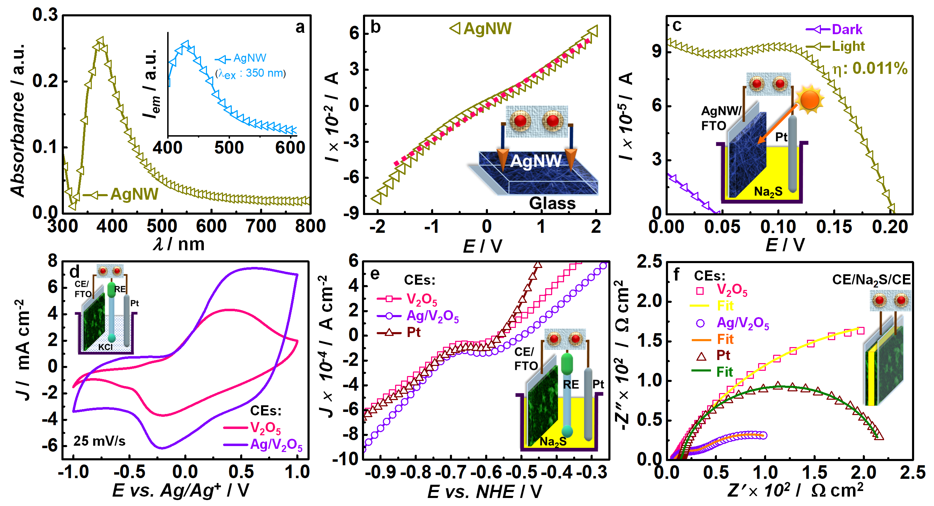

Figure 3 (a) Absorbance spectra of AgNW, inset is the emission spectra of AgNW at λ_{ex} = 350 nm. (b) I−V characteristics of a AgNW film. (c) J−V characteristics of a AgNW/FTO film under 100 mW cm⁻² irradiance and in dark, with a Pt CE, and in an aqueous 0.1 M Na₂S electrolyte. (d) CV plots of V₂O₅, Ag/V₂O₅ film on FTO with Pt CE in an aqueous 0.1 M KCl electrolyte. (e) LSV plots of V₂O₅, Ag/V₂O₅ and Pt films and (f) impedance spectra of symmetric cells of V₂O₅, Ag/V₂O₅ and Pt films. Insets of (b−f) show the corresponding experimental setups used for the measurements.

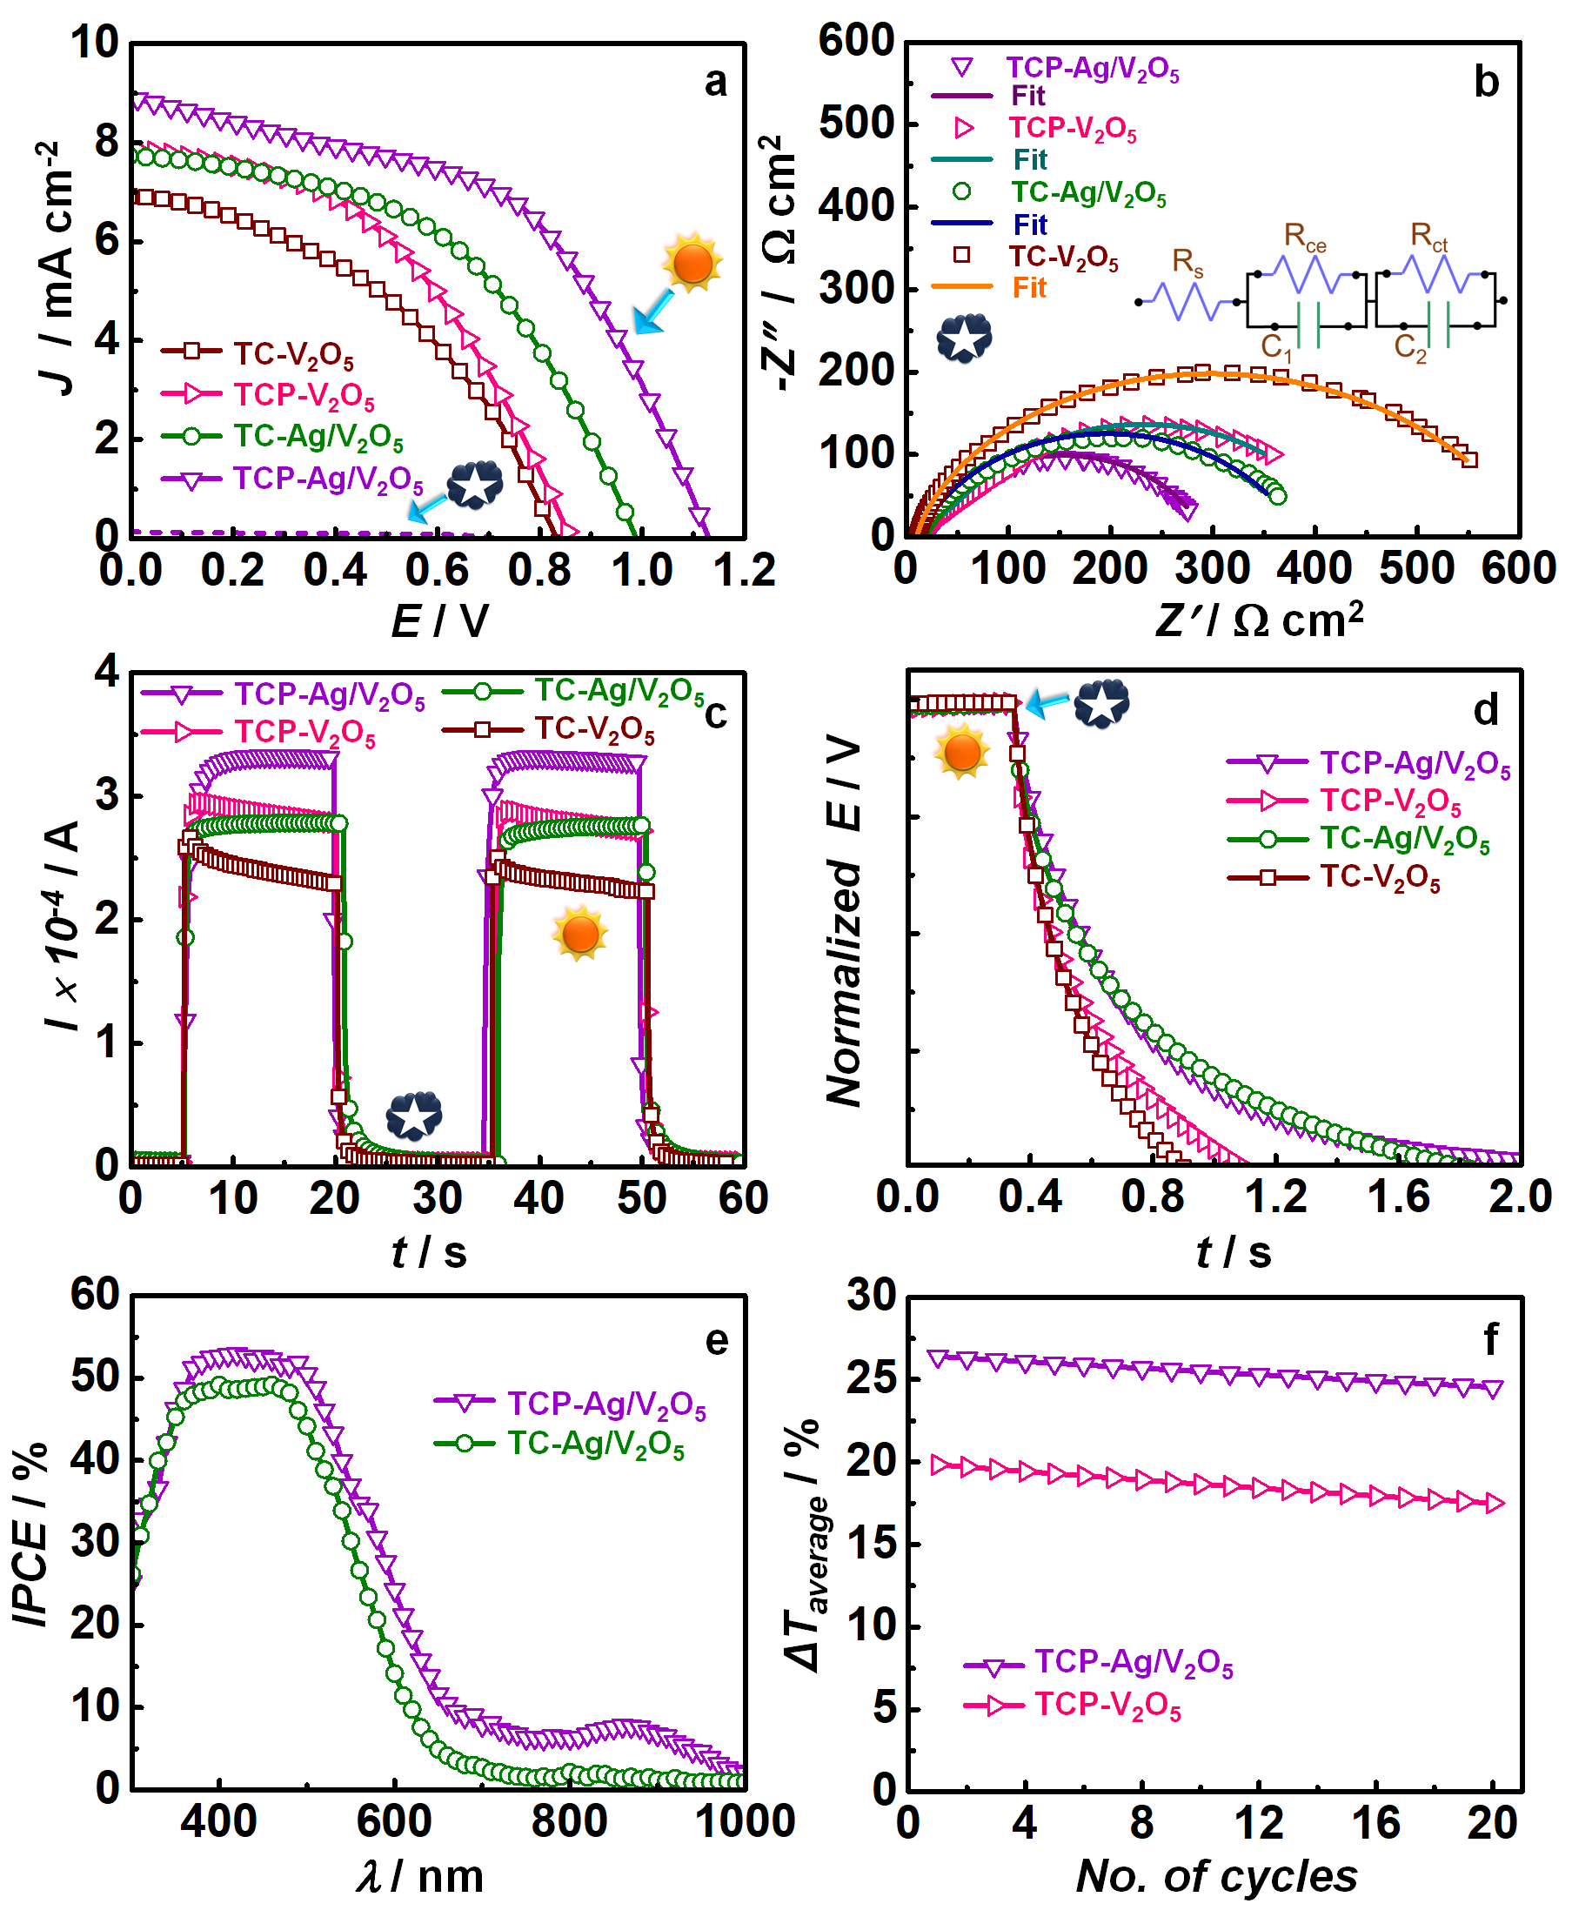
Figure 4 (a) J−V characteristics of PECDs with varying photoanodes and CEs in photoanode−S²⁻−CE configurations under a solar irradiance of 100 mW cm⁻² (AM 1.5G); T, C, and P are TiO₂, CdS and PbS layers. (b) Nyquist plots of the above mentioned PECDs in dark under forward bias of V_{OC}, (c) photocurrent- and (d) photovoltage decay- versus time plots of the PECDs, under white light irradiance. (e) IPCE versus wavelength curves for PECDs with photoanodes with/without the PbS QDs co-sensitization and Ag/V₂O₅ CEs. (f) Average transmittance modulation versus cycle numbers for the PECDs with the two different CEs V₂O₅, Ag/V₂O₅ films and same TiO₂/CdS/PbS photoanode.

Figure 5 Transmittance versus wavelength spectra of (a) TiO₂, TiO₂/CdS, TiO₂/CdS/Pbs films and the aqueous Na₂S electrolyte; (b) PECD with TiO₂/CdS/PbS−S²⁻−CE configurations (CE: V₂O₅ or Ag/V₂O₅ film), where they are colored under a sunlight applied for 30 s and bleached in dark. (c) CIE 1931 chromaticity diagram for the PECD. Transmittance versus wavelength spectra of (d) V₂O₅ film; and (e) Ag/V₂O₅ film in their as-fabricated states and the same films colored in the PECD configurations with TiO₂/CdS/PbS photoanodes under different illumination times and in their bleached states (bleached under dark). (f) CIE 1931 chromaticity diagram for the electrochromic films. Panel (a′) are the photographs of the below the photoanode films and electrolyte; (b′) PECD with TiO₂/CdS/PbS−S²⁻−Ag/V₂O₅ configuration showing colored and bleached state. Panels (d′) and (e′) are the photographs of the V₂O₅ and Ag/V₂O₅ films, respectively, colored under sunlight applied for 30 s, and bleached under dark in PECD configurations.

Figure 6 Coloration and bleaching kinetics (%T versus time) plots for PECDs with TiO₂/CdS/PbS (or TCP)−S²⁻−CE configurations (CE: Ag/V₂O₅ or V₂O₅ film) at a monochromatic wavelength of 650 nm.

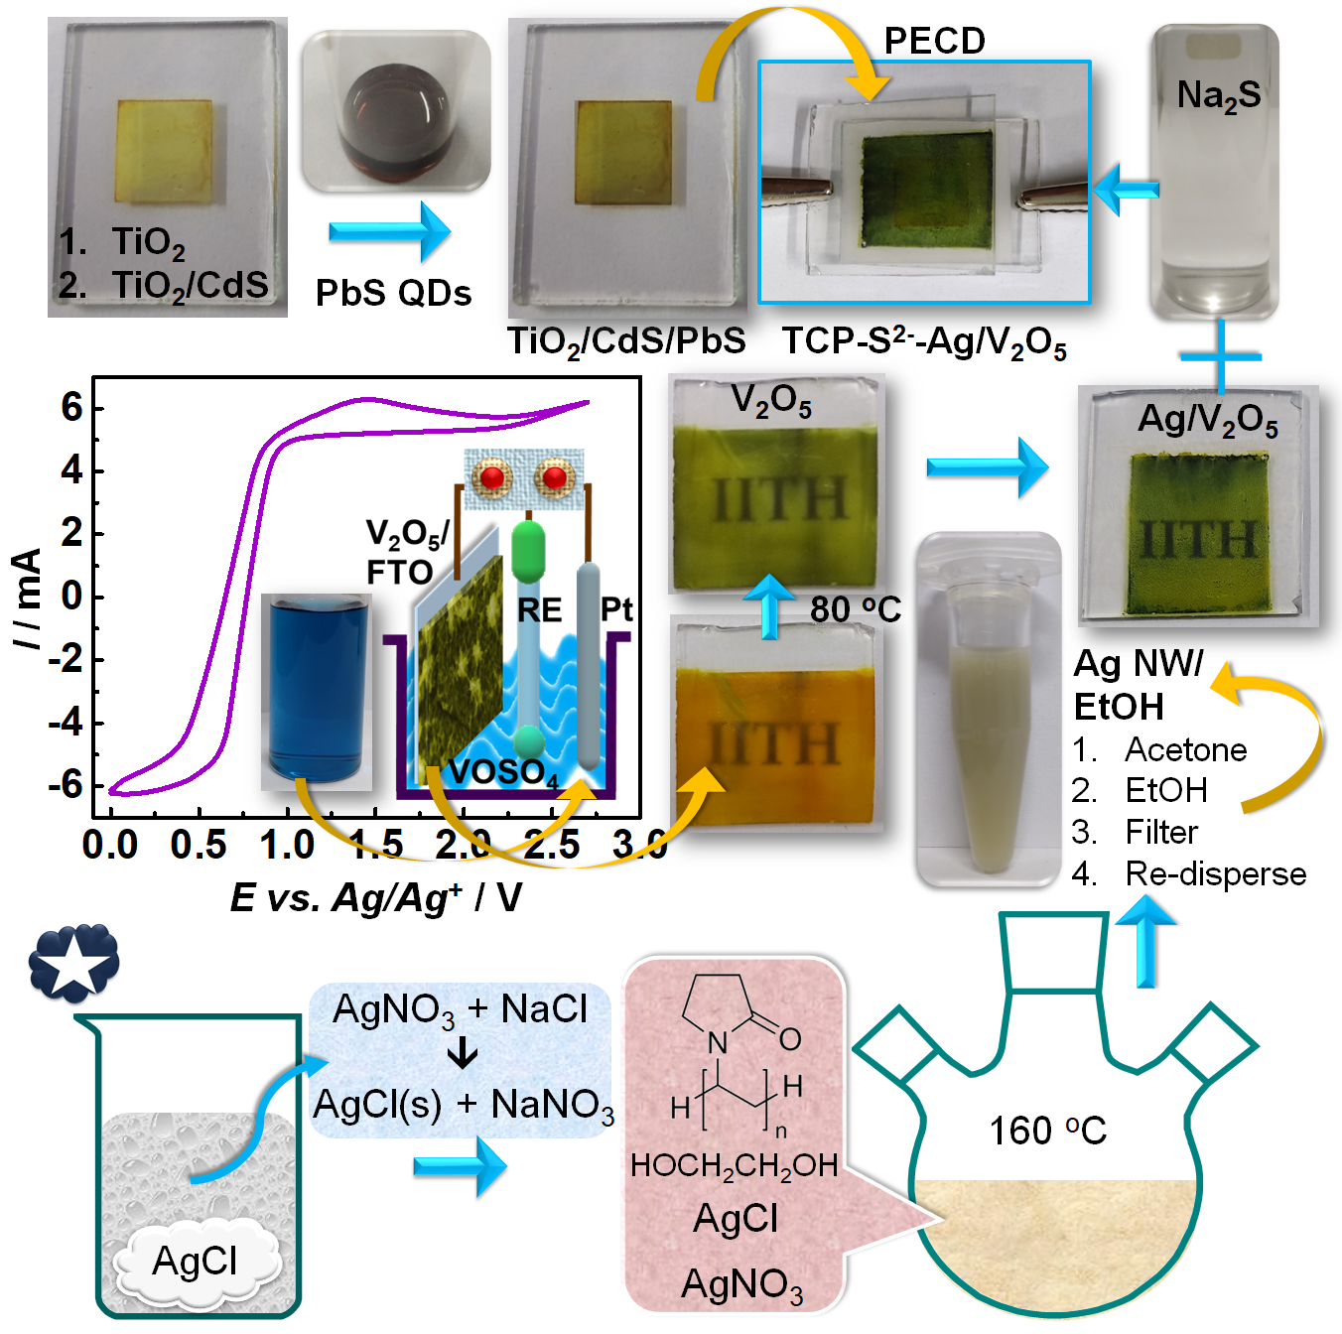

Scheme 1 Cartoon illustrating the preparation of photoanode, electrochromic CE and PECD fabrication process. The cyclic voltammogram was recorded during the electrodeposition of V₂O₅ film on FTO glass substrate from the blue colored vanadyl sulfate solution.

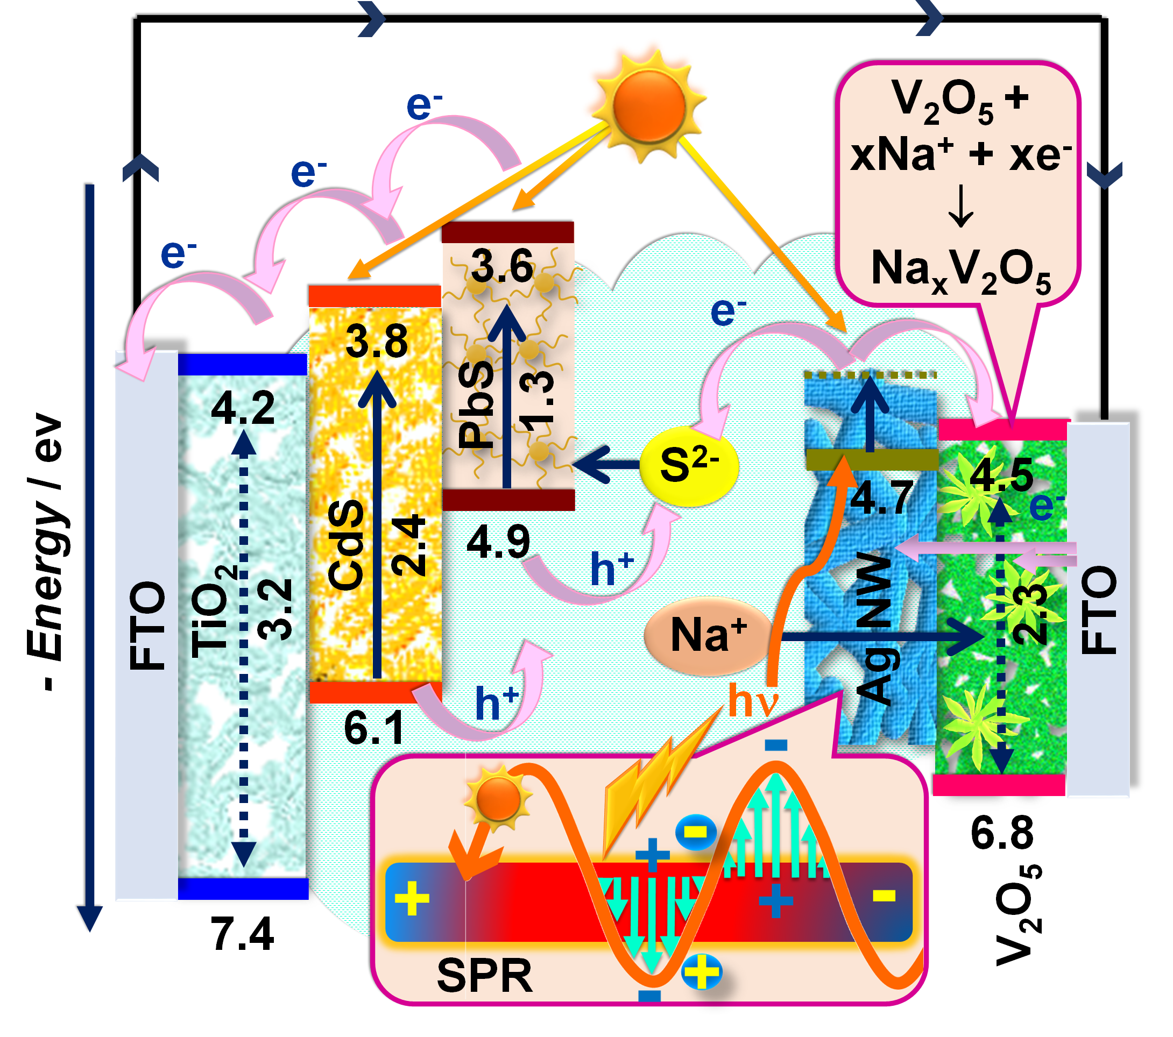

Scheme 2 Schematic illustrating electron−hole generation, and transfer processes in the photoanode under illumination and electron−ion injection−intercalation into the electrochromic counter electrode of the TiO₂/CdS/PbS-S²⁻-Ag/V₂O₅ PECD.

