Carrying the Work Forward: Reflections on My QEST Residency with Graham Moss
Theresa Easton 11084

In November 2024, I was awarded a Queen Elizabeth Scholarship Trust (QEST) scholarship of over £10,000 to work with Graham Moss of Incline Press and develop my skills in typesetting and letterpress printing. It was an opportunity to have time to learn directly from one of the finest letterpress printers I knew, and to bring that knowledge back into both my own studio at 36 Lime Street, Newcastle, and the Printmaking department at Newcastle University, where I teach part-time on the Fine Art programme.
What I could not have anticipated was how brief and precious that time would be. On 16 July 2025, just under six weeks after our final session together, Graham died unexpectedly. His absence is still difficult to grasp.

I had known Graham for over a decade, meeting him frequently at artist book fairs and wayzgooses, where our conversations often meandered between politics and printing. He was a strong supporter of Artists’ Union England, the trade union I helped to establish, and he generously donated prints to our Solidarity Fund during the Covid pandemic. His commitment to print was inseparable from his commitment to people, to justice, and to community.

When my scholarship began in December 2024, I made regular visits to Oldham, spending long weekends at Incline Press, working on projects with Graham and his partner, Helen Moss of Awen Press. My first lessons were in the fundamentals: relearning the lay of the case, which I had briefly studied years earlier at Robert Smail’s Printing Works. Graham set me to work on phrase of his: “If you want to leave footprints in the sands of time it’s probably best to wear your working shoes.”
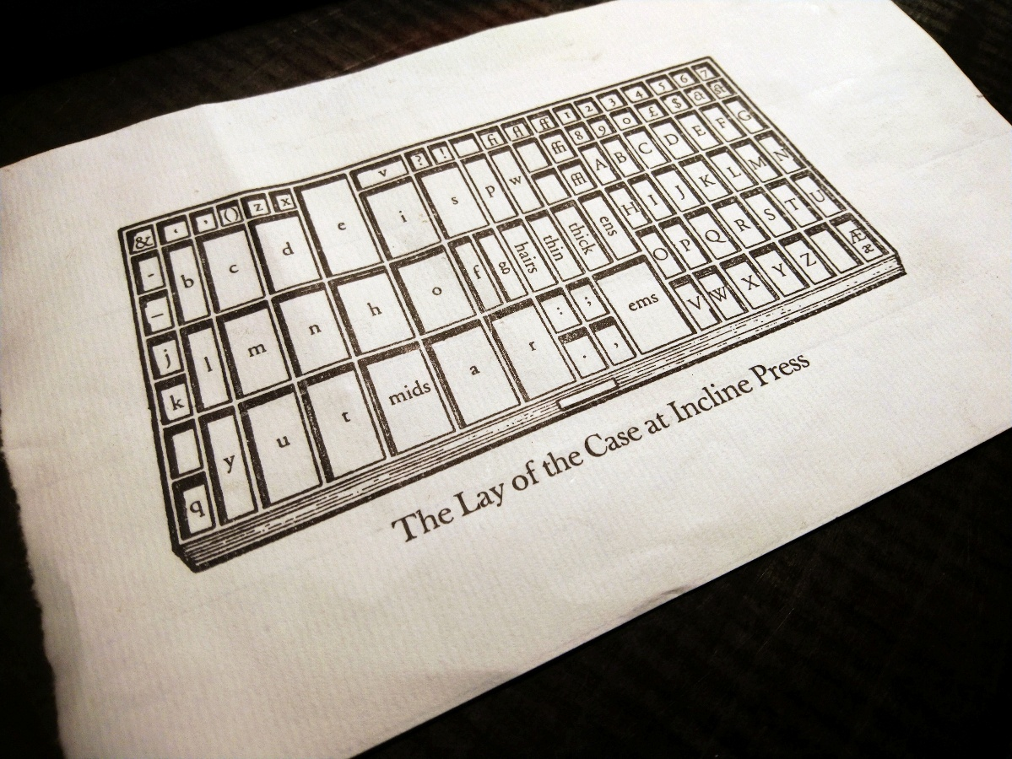

Learning the Lay of the Case

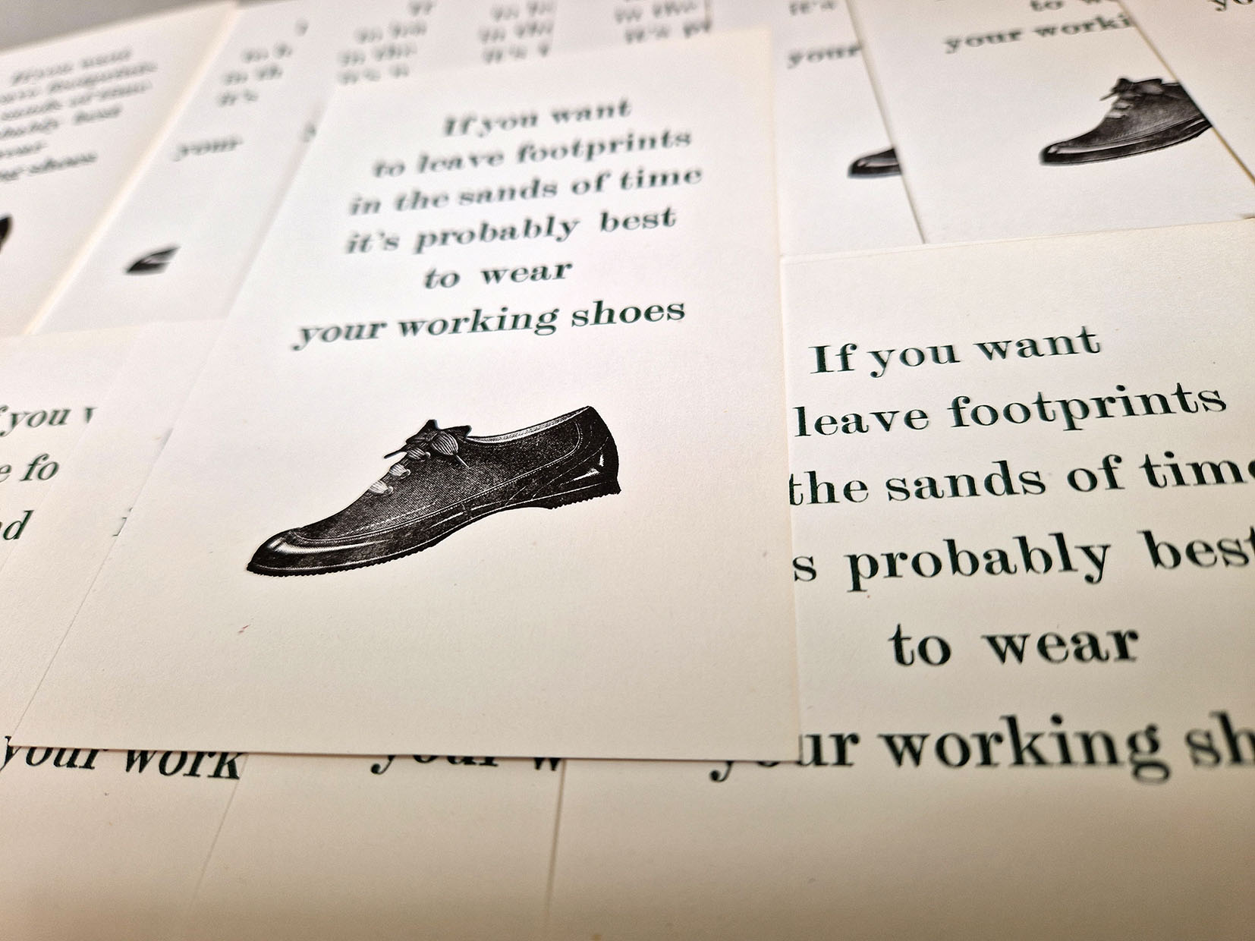
Footprints

From there, he and Helen guided me through the practicalities of setting type, printing with the Adana, and using a composing stick. Helen’s simple advice—the use of a finger cone—made the task infinitely easier, while Graham’s ingenious use of tympan and squared paper for registration opened whole new possibilities. These methods quickly found their way into my teaching at Newcastle, and into my own studio practice.

As I grew in confidence, I began to integrate letterpress with linocut—an area I usually taught but rarely explored in my own work. Inspired by Graham’s vast archive of illustrative blocks, and by Helen’s acrylic engravings for her book ‘Mary,’ I embarked on my first project: a small edition honouring the journalist and activist Ida B. Wells, informed by my ongoing work with African Lives in Northern England. Printing with both the Adana and Helen’s Albion press, I experimented with two-colour registration and hand-carved lino. The results, though modest, felt alive with potential.
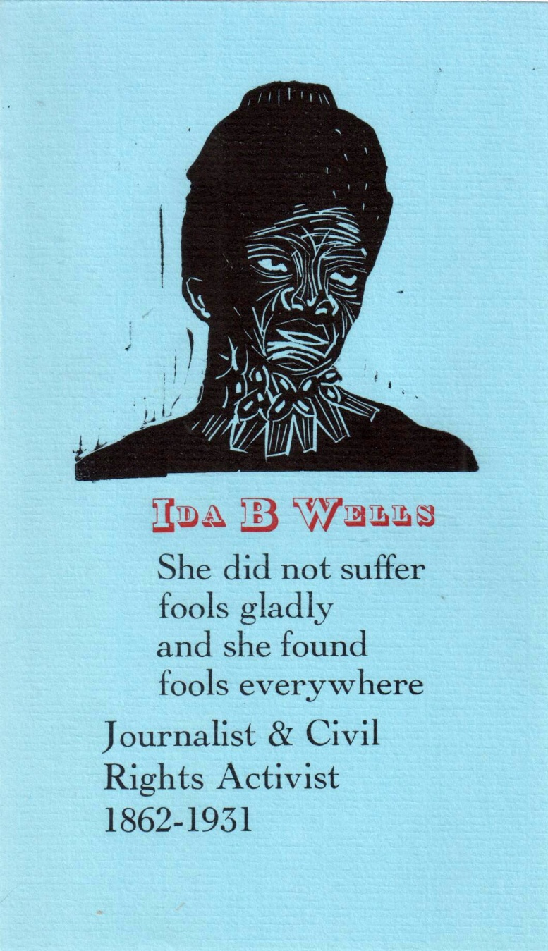
Ida B Wells

By early 2025, I was ready for greater challenges. A pamphlet project, inspired by Octavia E. Butler’s Parable of the Sower and Parable of the Talents, wove together Butler’s words with a political analysis of the LA fires from an article in The Morning Star. Graham, ever practical, guillotined 200 sheets of coloured paper for me, while I designed an Earthseed-inspired ornament for the front page. This project stretched across several visits, but each stage deepened my skills and sharpened my eye for design.
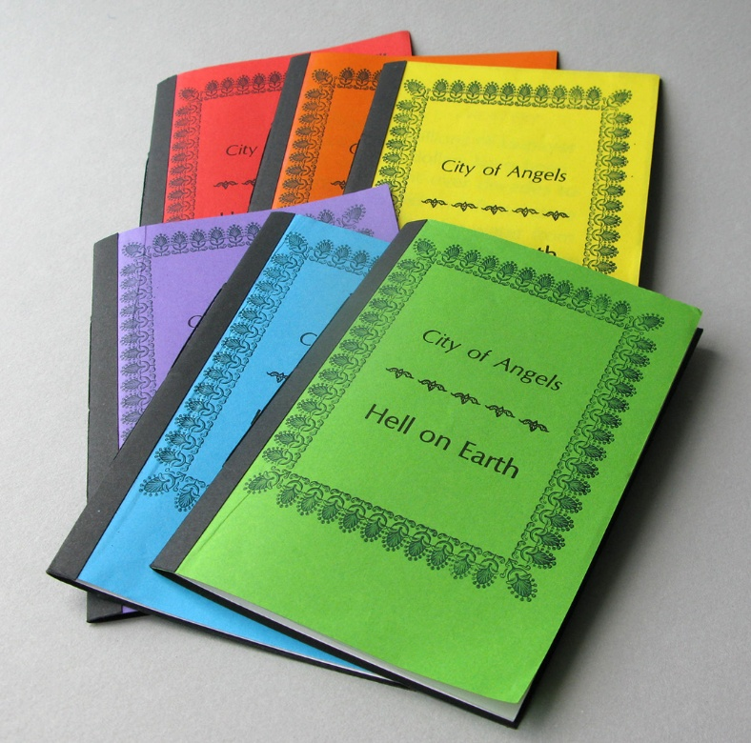
City of Angels, Hell on Earth

My weekends in Oldham were always interspersed with time in my own studio, where I began reorganising the space, refining techniques, and imagining new collaborations. One such collaboration has been with poet and artist Sheree Mack, where letterpress becomes a meeting point between words, history, and new creative possibilities.

Opportunities soon began to grow out of this period of learning. I was invited by Angie Butler, Senior Research Fellow at UWE’s Centre for Print Research, to contribute to a Women Artist-Printers Portfolio Project on the theme of Allyship, to be showcased at the Woolwich Print Fair in 2025. I returned to Ida B. Wells for this project, reflecting on her allyship with Frederick Douglass, and questioning what allyship looks like today.

Another project, inspired by an article by Katherine Anteney 10784 in Small Printer, saw me producing a leporello with linocuts using my studio Adana press. And in celebration of Newcastle’s Literary and Philosophical Society’s 200th anniversary, I designed and printed a small edition honouring Emily Faithfull, the pioneering women’s rights advocate who established a female-run press. Graham lent me an exquisite block of a woman at a platen press for the work—an image that now feels all the more significant.
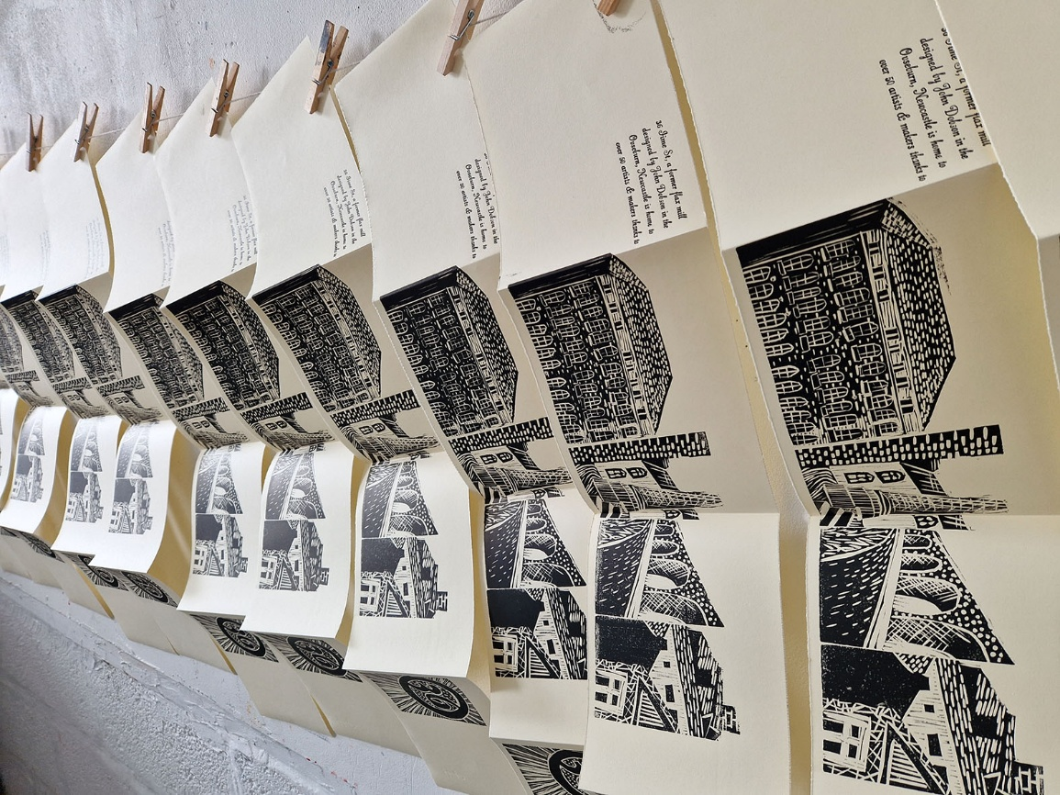
Leporello Prints

What I carry forward most from my time at Incline Press is not simply technical skill, but a sense of belonging to the letterpress community. Graham’s workshop was alive with history—broadsheets, posters, and ephemera that told the story of printing as both craft and political tool. His generosity, his humour, and his anarchic spirit made learning from him a joy.

I miss his passion for print and for social justice, but I also feel the responsibility to continue the work—to share what he taught me with students, collaborators, and fellow artists. This residency was not only an education, but a gift of friendship and inspiration. My QEST scholarship was meant to support the development of my practice. In truth, it also gave me a teacher whose influence will remain with me, long after the ink has dried.

